
MODULE CODE & TITLE:
CT073-3-2 Computer System Low Level Techniques (CSLLT)
PROJECT TITLE:
EVO PARKING Terminal

STUDENT NAME | MD KABIDUZZAMAN
STUDENT ID | TP089528
INTAKE CODE | APU2F2602CS(AI)
LECTURER NAME | DR. HASSAN JAMIL SYED
DATE DUE | 19th October 2026
Table of Contents
1.0 INTRODUCTION ON ASSEMBLY LANGUAGE 3
1.1 Overview of Low-Level Assembly Programming 3
1.2 The 32-Bit x86 (IA-32) Processor Architecture and Registers 3
1.3 Linux NASM Memory Segmentation (.data, .bss, .text) 4
1.4 Fundamental Operations: Arithmetic, Loops, and Branching Jumps 4
1.5 Linux Kernel System Calls (int 0x80) 5
2.0 RESEARCH AND ANALYSIS 5
2.1 Direct Hardware Interaction and Resource Efficiency in Modern Disciplines 5
3.0 SYSTEM DESIGN 8
3.1 System Overview and Functional Specifications 8
3.2 Business Rules, Tariff Schedule, and Clamping Enforcement 9
3.3 Logical System Assumptions 9
3.4 Main System Flowchart 11
3.5 Checkout, Tariff Calculation, and Receipt Sub-Flowchart (Option 4) 12
3.6 Admin Authentication and Settings Sub-Flowchart (Option 8) 12
4.0 SYSTEM SCREENSHOTS AND TEST CASES 13
4.1 Test Case 1: Compilation, Linking, and Main Menu Execution 13
4.2 Test Case 2: Standard & EV Check-In and "All Bays Occupied" Detection 13
4.3 Test Case 3: Live Ultrasonic Sensor Telemetry & Pricing Schedule 14
4.4 Test Case 4: Admin Login, IoT Clock Simulation, and Manual Barricade Override 14
4.5 Test Case 5: Checkout, Clamping Penalty Calculation, and Official Receipt 15
4.6 Test Case 6: Customer Feedback Submission and Admin Feedback Log Viewer 16
5.0 SOURCE CODE WITH EXPLANATION 17
5.1. Memory Segmentation — Menus & Tariff Table 17
5.2. Prompts, Receipt Templates & Admin Strings 19
5.3. Hardware Sensor Arrays, State Variables & Uninitialized Buffers (.data & .bss) 23
5.4. Program Entry Point & Main Menu Dispatcher (_start & main_loop) 24
5.5. Live Bay Telemetry Loops 26
5.6. Pre-Check-In Full-Lot Scan & Vehicle Check-In 29
5.7. Checkout Validation & Multi-Tier Tariff Arithmetic 31
5.8. Payment Gateway & Itemized Official Receipt Generator 33
5.9. Tariff Display, Customer Feedback Logger & Support Info 36
5.10. Session-Based Admin Settings & IoT Sensor Clock Simulator 37
5.11. Clean System Termination & Subroutines 40
6.0 CONCLUSION 43
7.0 REFERENCES 44
8.0 APPENDICES 44
Appendix A: 32-Bit x86 Register Allocation Map 44
Appendix B: Environment Setup and Compilation Guide (Linux / GitHub Codespaces) 45
Appendix C: Softcopy User Manual & Step-by-Step Operation Guide 46
C.1 Overview of the Terminal Interface 46
C.2 Driver Operation Guide (Standard & EV Customers) 46
C.3 Administrator Operation Guide (Management & Security Controls) 50
C.4 Troubleshooting & Common Error Messages 51

1.0 INTRODUCTION ON ASSEMBLY LANGUAGE

1.1 Overview of Low-Level Assembly Programming
Assembly language is a low-level symbolic programming language that provides a direct, one-to-one correspondence between human-readable mnemonics and native processor machine code instructions. Unlike high-level programming languages (such as C, Java, or Python) that abstract away hardware details through compilers, interpreters, and virtual machines, assembly language operates directly on the physical processor architecture. This direct hardware relationship grants programmers granular control over CPU registers, memory addressing modes, processor status flags (EFLAGS), and operating system interrupts.

1.2 The 32-Bit x86 (IA-32) Processor Architecture and Registers
The 32-bit x86 architecture (Intel IA-32) utilizes a Complex Instruction Set Computer (CISC) design featuring eight 32-bit General-Purpose Registers (GPRs), a 32-bit Instruction Pointer (EIP), and a 32-bit Flags Register (EFLAGS):
- EAX (Extended Accumulator Register): Used as the primary accumulator for arithmetic operations (MUL, DIV, ADD, SUB), Linux system call numbers, and function return values. Can be accessed in 16-bit (AX) or 8-bit (AH, AL) sub-registers.
- EBX (Extended Base Register): Serves as a base pointer for memory array indexing and holds the first argument (such as a file descriptor) during Linux kernel interrupts.
- ECX (Extended Counter Register): Functions as the hardware loop counter for iterative instructions (LOOP) and holds memory buffer addresses during sys_read and sys_write calls.
- EDX (Extended Data Register): Works alongside EAX during 32-bit multiplication (MUL) and division (DIV stores the quotient in EAX and the remainder in EDX), and specifies byte lengths during I/O system calls.
- ESI and EDI (Extended Source and Destination Index): Used for high-speed array traversal, pointer indexing, and byte-by-byte string comparisons (verify_str).
- ESP and EBP (Extended Stack Pointer and Base Pointer): Manage the hardware Last-In, First-Out (LIFO) stack in memory via PUSH, POP, CALL, and RET instructions.

1.3 Linux NASM Memory Segmentation (.data, .bss, .text)
In 32-bit Linux assembly using the Netwide Assembler (NASM), an Executable and Linkable Format (elf32) program is divided into three primary memory sections:
- section .data: Stores initialized static data, including ASCII menu prompts, tariff tables, status arrays (slots), and initialized state variables (revenue, slot_hours). Memory is allocated using db (Define Byte, 8-bit), dw (Define Word, 16-bit), and dd (Define Doubleword, 32-bit).
- section .bss (Block Started by Symbol): Reserves uninitialized memory buffers for runtime user input and string formatting (in_buf, fb_buf, num_buf) using resb (Reserve Byte).
- section .text: Contains the executable machine instructions, subroutines, and the global entry point (global _start) recognized by the GNU linker (ld).

1.4 Fundamental Operations: Arithmetic, Loops, and Branching Jumps
To build a functional software system at the assembly level, three core categories of instructions are required:
- Arithmetic Operations: Instructions such as ADD, SUB, INC, DEC, MUL (unsigned multiply), IMUL (signed multiply), and DIV (unsigned divide) manipulate binary integers directly inside registers and memory locations.
- Loops (Iterative Processes): Iterative execution is achieved either through the dedicated LOOP instruction (which automatically decrements ECX and branches if ECX != 0) or by combining an index counter (ESI), a comparison (CMP), and a conditional jump (JL, JGE, JNZ).
- Jumps (Conditional and Unconditional Branching): Unconditional jumps (JMP) alter the Instruction Pointer (EIP) immediately to implement state machines and menu loops. Conditional jumps (JE, JNE, JL, JLE, JG, JGE) inspect the CPU EFLAGS register (specifically the Zero Flag ZF, Sign Flag SF, and Overflow Flag OF) set by a preceding CMP or TEST instruction to implement if-else decision logic.

Core Construct | Assembly Instructions Used in system | Subroutines / Labels in parking.asm
Arithmetic Operations | MUL, IMUL, DIV, ADD, SUB, INC, DEC | calc_std_pricing, calc_ev_pricing, prompt_payment, simulate_sensor_clock, customer_feedback, read_int, print_int_no_nl
Loops (Iterative Processes) | LOOP, JMP + INC + CMP/JGE, JNZ | std_view_loop, ev_view_loop, check_std_full_loop, check_ev_full_loop, sim_loop, verify_str (.cmp_loop), read_int (.parse_loop), print_int_no_nl (.div_loop)
Jumps (Conditional & Unconditional) | JE, JNE, JL, JLE, JG, JGE, JNZ, JMP | main_loop, settings_loop, payment_loop, checkout_car, generate_receipt, admin_login

1.5 Linux Kernel System Calls (int 0x80)
In a 32-bit Linux environment, user-space programs interact with terminal hardware (keyboard input and screen output) by invoking software interrupt 0x80 (int 0x80). The system call number is loaded into EAX (1 for sys_exit, 3 for sys_read, 4 for sys_write), while parameters are passed in EBX, ECX, and EDX.

2.0 RESEARCH AND ANALYSIS

2.1 Direct Hardware Interaction and Resource Efficiency in Modern Disciplines

2.1.1 The Enduring Necessity of Assembly Language in Modern Computing
While contemporary software engineering predominantly utilizes high-level languages (such as C++, Python, Rust, and Java) to accelerate cross-platform development, high-level compilers inevitably introduce abstraction layers, non-deterministic instruction scheduling, and larger memory footprints (Irvine, 2020). Assembly language remains indispensable in specialized engineering domains because it provides a one-to-one correspondence with native processor machine instructions, allowing developers to manipulate CPU registers, memory-mapped I/O ports, and hardware interrupts directly without runtime overhead (Duntemann, 2023). In mission-critical environments governed by strict Size, Weight, and Power (SWaP) constraints or hard real-time deadlines, assembly language guarantees deterministic clock-cycle execution that high-level languages cannot match (Intel Corporation, 2024).

2.1.2 Critical Analysis of Industries and Disciplines Utilizing Assembly Language
- Embedded Systems, Automotive Microcontrollers, and Industrial IoT Telemetry: In ultra-low-power embedded systems—such as automotive Electronic Control Units (ECUs) for Anti-Lock Braking Systems (ABS), implantable biomedical devices (cardiac pacemakers), and smart city IoT sensor nodes (mirrored in our Smart Parking terminal’s ultrasonic bay sensors)—microcontrollers often operate with only a few kilobytes of SRAM and Flash ROM (Carter, 2019). High-level language features such as dynamic garbage collection, exception handling tables, and standard library runtimes consume excessive memory and battery power. By writing sensor polling loops and interrupt service routines (ISRs) directly in assembly language, embedded engineers communicate directly with General-Purpose Input/Output (GPIO) hardware registers, achieving sub-microsecond response times and extending battery longevity across thousands of deployed IoT nodes (Irvine, 2020).
- Operating System Kernels, Bootloaders, and Hardware Context Switching: No high-level programming language can execute on bare silicon immediately after power-on because a compiled C or Rust program requires an initialized stack pointer (ESP/RSP), configured segment descriptors, and an active virtual memory paging table (Intel Corporation, 2024). Consequently, system bootloaders (such as UEFI firmware phases and GNU GRUB) rely on hand-written assembly code to test physical RAM, configure x86 control registers (CR0–CR4), initialize the Global Descriptor Table (GDT), and transition the CPU from 16-bit Real Mode into 32-bit Protected Mode or 64-bit Long Mode (Duntemann, 2023). Furthermore, modern operating system kernels—including the Linux kernel (arch/x86/entry/)—use assembly language for hardware trap gates (int 0x80 and syscall) and process context switching, where the exact state of all general-purpose registers (EAX–EDI and EFLAGS) must be pushed to and popped from the kernel stack without compiler interference (The NASM Development Team, 2024).
- Cryptographic Engineering and Side-Channel Attack Mitigation: Production cryptographic libraries—including OpenSSL, BoringSSL, and WolfSSL—implement their core encryption and hashing primitives (such as AES, SHA-256, and Elliptic Curve Cryptography) directly in x86 and ARM assembly language (Intel Corporation, 2024). This serves two vital purposes. First, assembly allows cryptographers to utilize specialized hardware instructions such as Intel AES-NI and 512-bit Single Instruction, Multiple Data (AVX-512) vector registers, accelerating TLS/HTTPS encryption throughput by over an order of magnitude. Second, high-level optimizing compilers frequently optimize away security checks or introduce data-dependent conditional branches (JE/JNE) that leak secret key bits through CPU cache-timing variations. Writing cryptographic routines in assembly guarantees constant-time execution, neutralizing timing side-channel vulnerabilities (Carter, 2019).
- High-Frequency Trading (HFT), Multimedia Codecs, and Digital Signal Processing (DSP): In real-time video encoding engines (such as FFmpeg, x264, and DAV1D) and ultra-low-latency financial trading systems, every CPU clock cycle directly impacts throughput. Multimedia engineers write motion-estimation and discrete cosine transform (DCT) inner loops in assembly using SIMD vectorization to process 16 to 64 pixels in a single instruction cycle, enabling real-time 4K/8K video streaming on consumer hardware (Irvine, 2020).

2.1.3 Summary of Assembly Language Industry Applications
Discipline / Industry Sector | Primary Technical Reason for Assembly Usage | Specific Hardware / Architectural Features Targeted
Embedded Systems & IoT Sensors | Extreme RAM/ROM constraints; elimination of runtime library overhead; minimal power draw (Carter, 2019). | Memory-mapped GPIO ports, hardware timers, watchdog registers, and hardware interrupts.
OS Kernels & Bootloaders | Bare-metal CPU initialization prior to C runtime stack availability; atomic register saving (Duntemann, 2023). | Control registers (CR0–CR4), GDT/IDT tables, stack pointer (ESP), and int 0x80 / syscall traps.
Cryptography & Security Libraries | Hardware acceleration and prevention of compiler-induced timing side-channel leaks (Intel Corporation, 2024). | AES-NI hardware instructions, AVX-512 / SSE vector registers, and constant-time arithmetic.
Multimedia Codecs & DSP Engines | Maximum frame-rate throughput and cache-line alignment for real-time audio/video processing (Irvine, 2020). | SIMD parallel vector registers (MMX, SSE4, AVX2) and L1/L2 CPU cache prefetching.

3.0 SYSTEM DESIGN

3.1 System Overview and Functional Specifications
The Smart Parking & EV Charging Terminal is a menu-driven automated carpark management prototype developed in 32-bit x86 Linux NASM assembly. It manages a 7-bay facility comprising 5 Standard Parking Bays (Bays 1–5) and 2 Electric Vehicle (EV) Charging Bays (Bays 6–7).
The system implements the following core modules:
- Live Bay Telemetry Display: Visualizes occupancy status and logged ultrasonic timer durations across all 7 bays.
- Automated Full-Lot Detection & Check-In: Scans Standard Bays (1–5) or EV Bays (6–7) prior to check-in. If all bays in the requested category are occupied, it blocks check-in and prints an apology notice; otherwise, it activates the bay sensor (1) and starts the timer at 1 hour.
- Automated Sensor Checkout & Itemized Receipt Printer: Reads elapsed hours from the bay sensor, applies tiered hourly rates and wheel-clamping fines, processes payment (Cash, Card, or Touch 'n Go / DuitNow QR), and prints a complete itemized receipt.
- Tariff Schedule, Customer Feedback & Helpdesk Support: Displays full pricing tables, records free-text customer complaints into memory (fb_buf), and provides 24/7 unclamping hotline details.
- Session-Based Admin Control Panel: Protected by a single login gate (admin / 1234), allowing administrators to simulate IoT sensor clock advances (+Hours), view cumulative daily revenue (RM), manually unlock barricades (Bays 1–7 or Main Gate 0), and read submitted customer feedback.

3.2 Business Rules, Tariff Schedule, and Clamping Enforcement
Bay Category | Bay Numbers | Normal Tier (1–24 Hours) | Extended Tier (25–48 Hours) | Overstay & Clamping Tier (>48 Hours)
Standard Parking | Bays 1 – 5 | RM 5 / hour | RM 10 / hour | Wheel Clamped! Capped at 48h (RM 480) + RM 100 Fine = RM 580
EV Charging Station | Bays 6 – 7 | RM 8 / hour | RM 12 / hour | Wheel Clamped! Capped at 48h (RM 576) + RM 150 Fine = RM 726

3.3 Logical System Assumptions
The following logical assumptions are taken into consideration during system execution:
- Volatile Memory State: Bay occupancy (slots), timers (slot_hours), revenue (revenue), and customer feedback (fb_buf) reside in RAM and persist for the duration of the terminal session.
- Integer Hour & Currency Arithmetic: All time durations (hours) and monetary amounts (RM) are processed as 32-bit unsigned integers, avoiding floating-point inaccuracies.
- Minimum 1-Hour Entry Billing: Triggering an ultrasonic bay sensor upon check-in initializes the bay timer to 1 hour.
- 48-Hour Maximum Billable Cap on Clamped Vehicles: Vehicles exceeding 48 hours are wheel-clamped; their hourly fee is capped at the 48-hour extended limit plus the flat clamping fine (RM 100 Standard / RM 150 EV).

3.4 Main System Flowchart
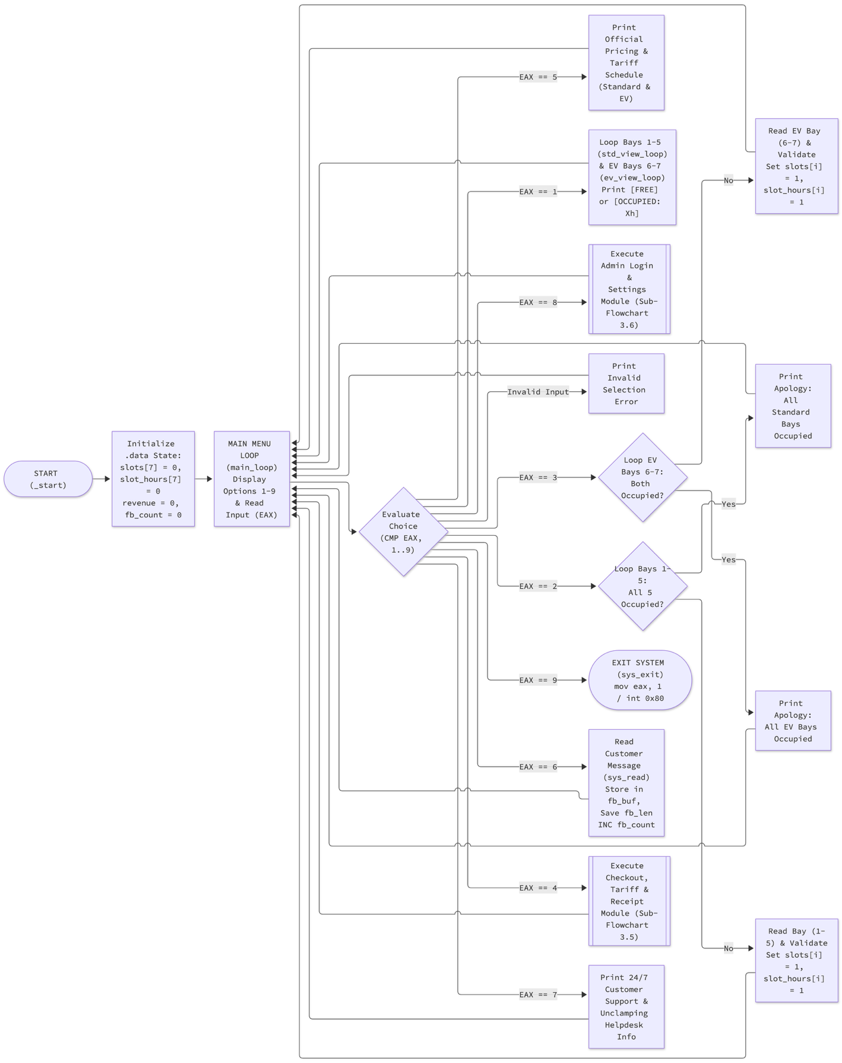

3.5 Checkout, Tariff Calculation, and Receipt Sub-Flowchart (Option 4)
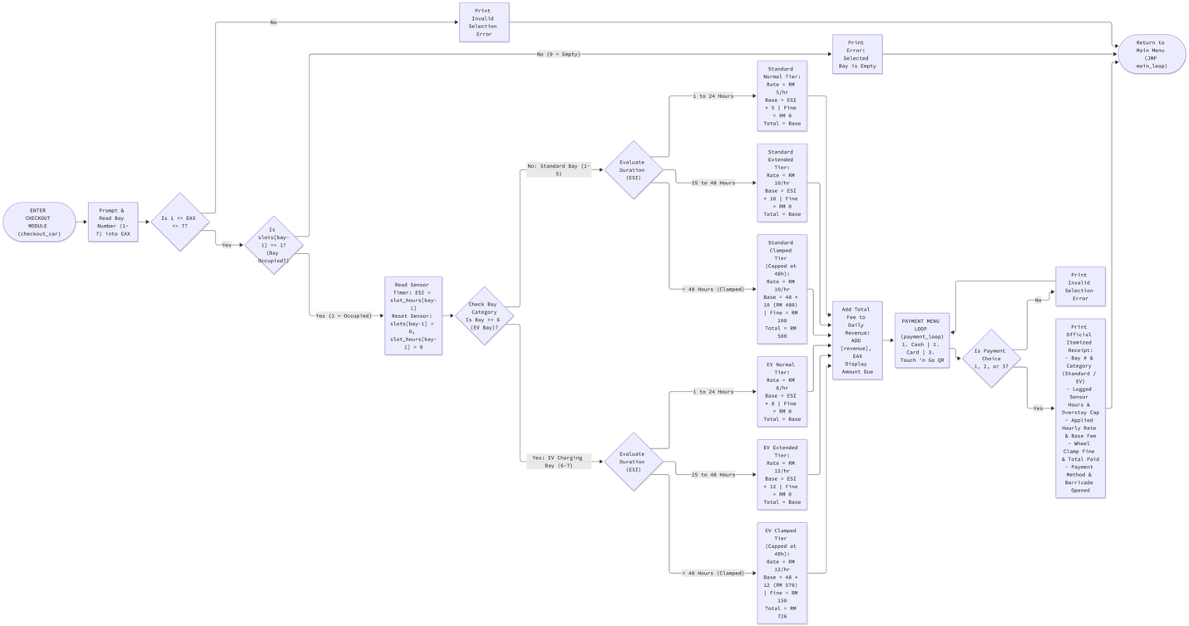

3.6 Admin Authentication and Settings Sub-Flowchart (Option 8)
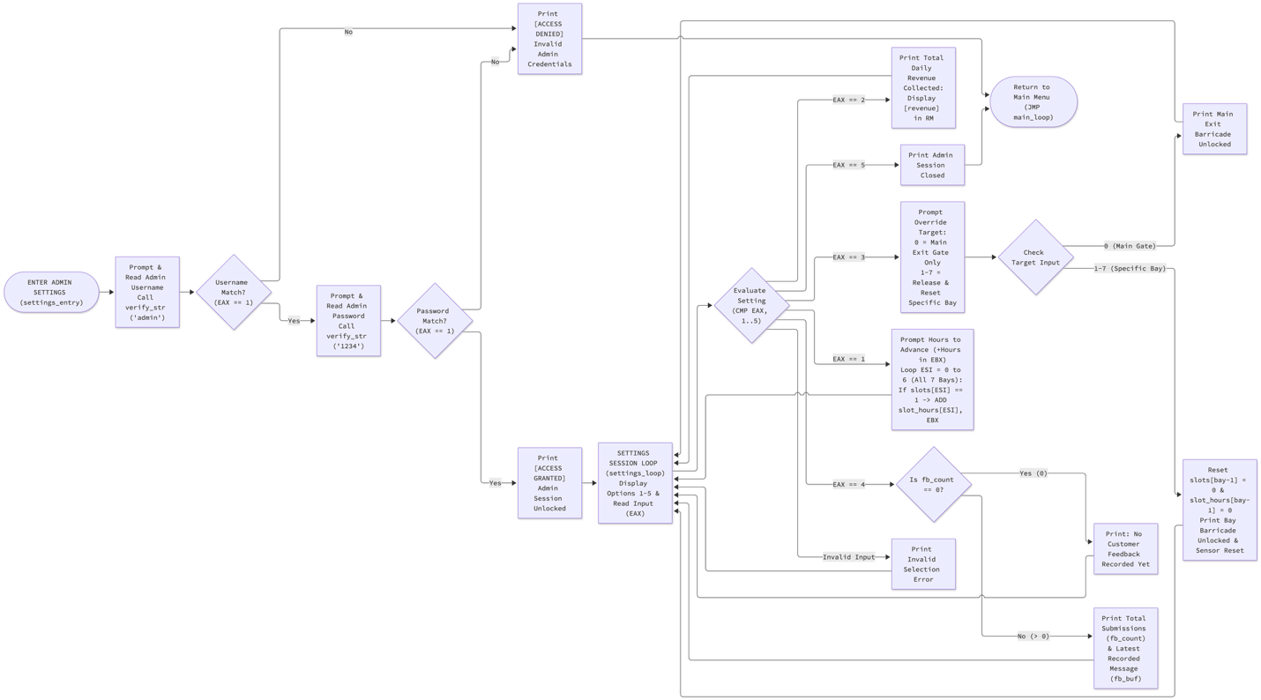

4.0 SYSTEM SCREENSHOTS AND TEST CASES

4.1 Test Case 1: Compilation, Linking, and Main Menu Execution

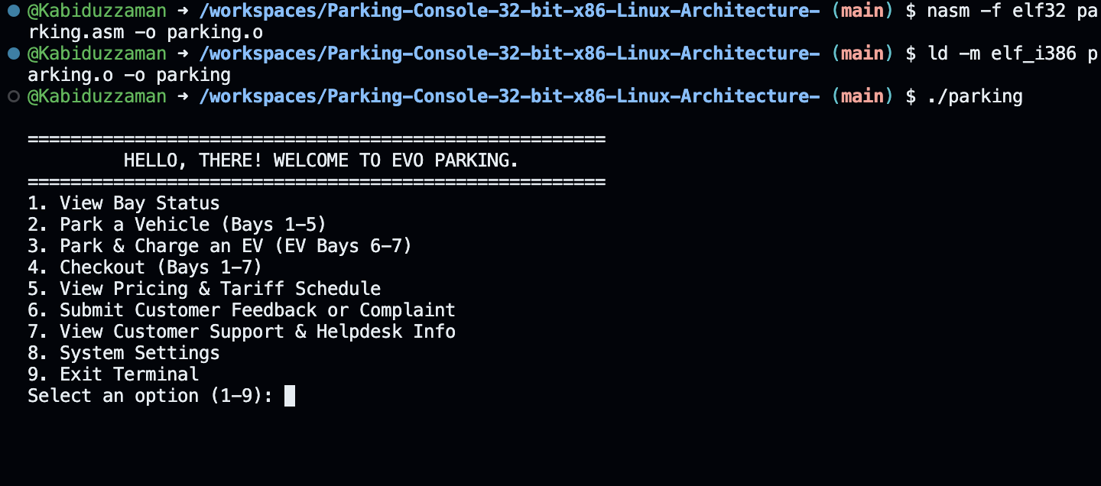

4.2 Test Case 2: Standard & EV Check-In and "All Bays Occupied" Detection

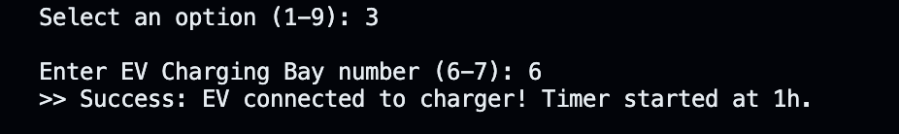
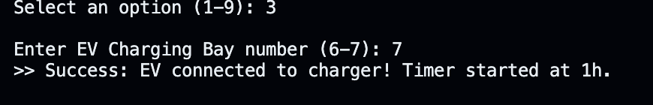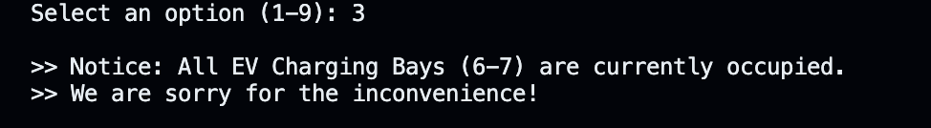

4.3 Test Case 3: Live Ultrasonic Sensor Telemetry & Pricing Schedule
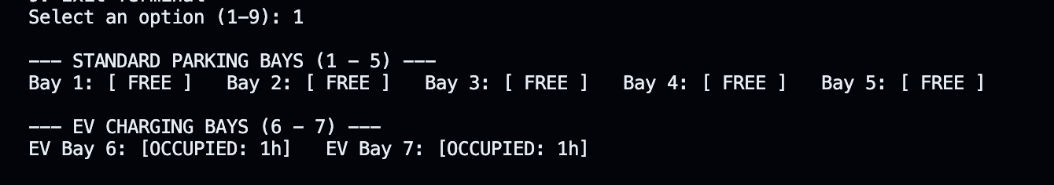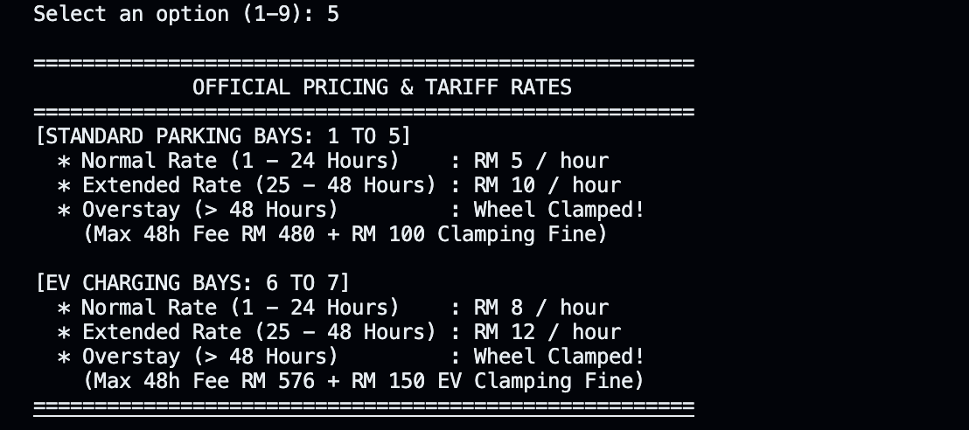

4.4 Test Case 4: Admin Login, IoT Clock Simulation, and Manual Barricade Override
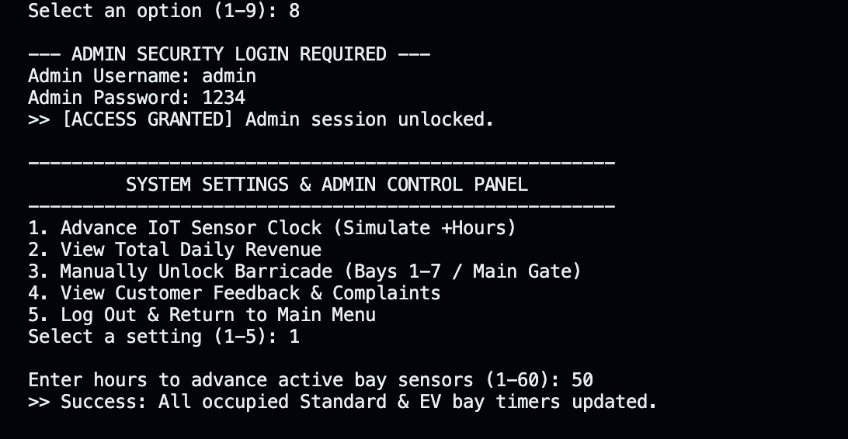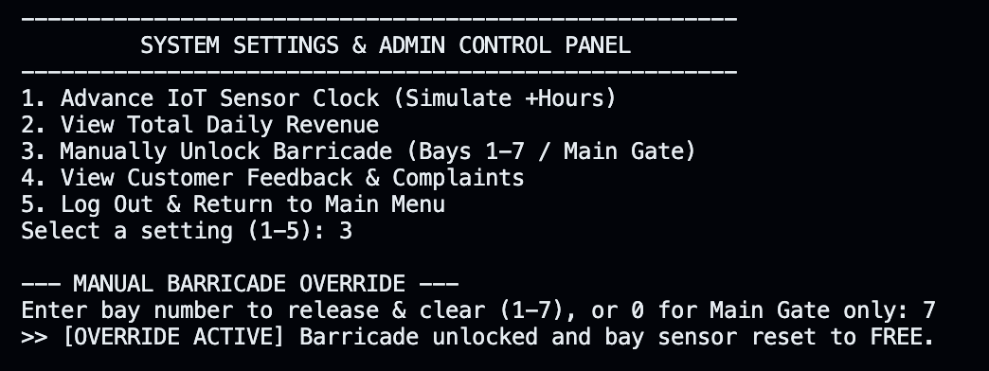

4.5 Test Case 5: Checkout, Clamping Penalty Calculation, and Official Receipt

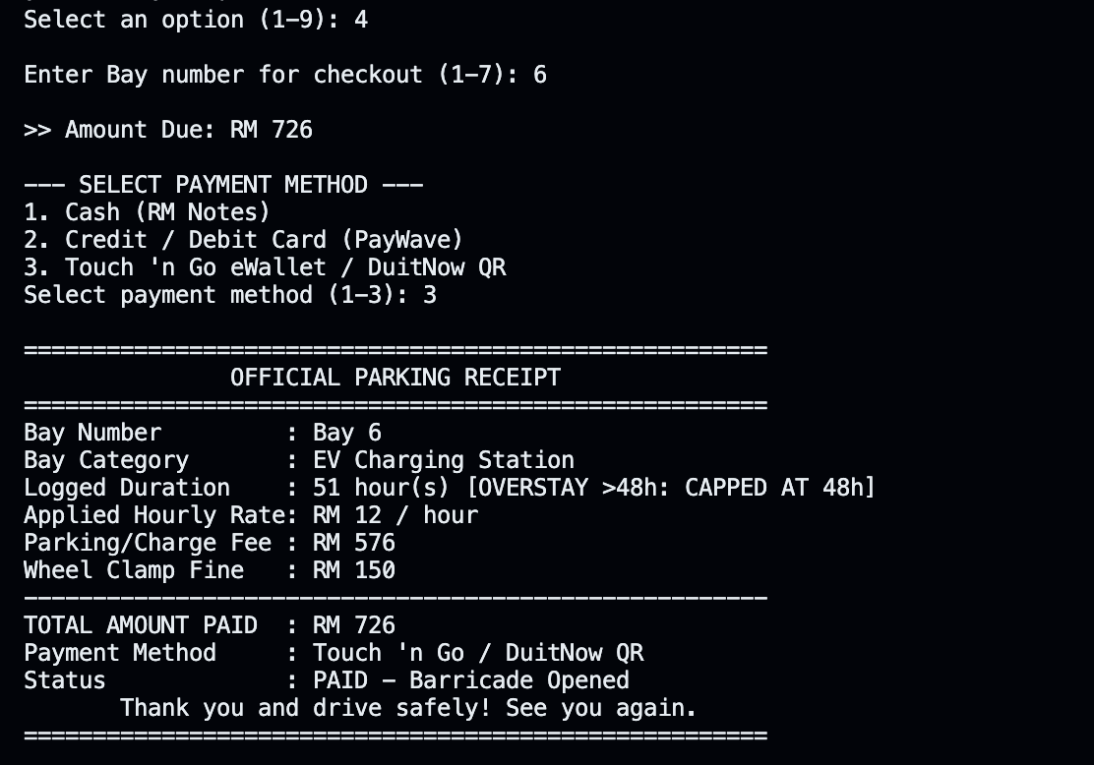

4.6 Test Case 6: Customer Feedback Submission and Admin Feedback Log Viewer

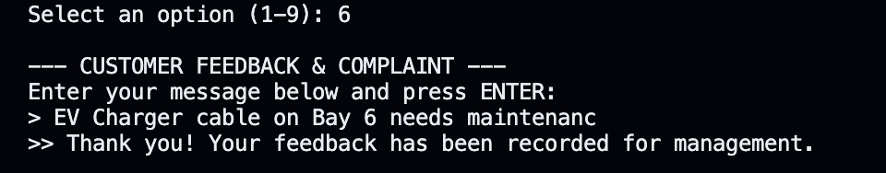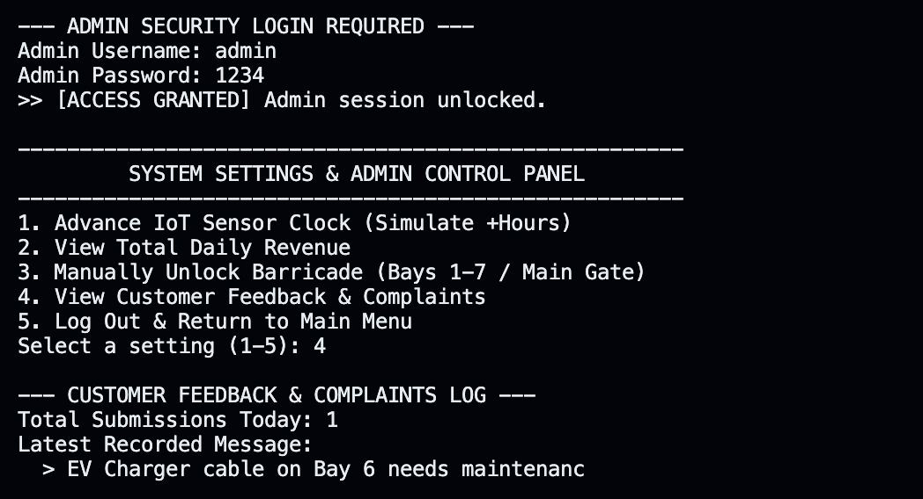

5.0 SOURCE CODE WITH EXPLANATION

5.1. Memory Segmentation — Menus & Tariff Table

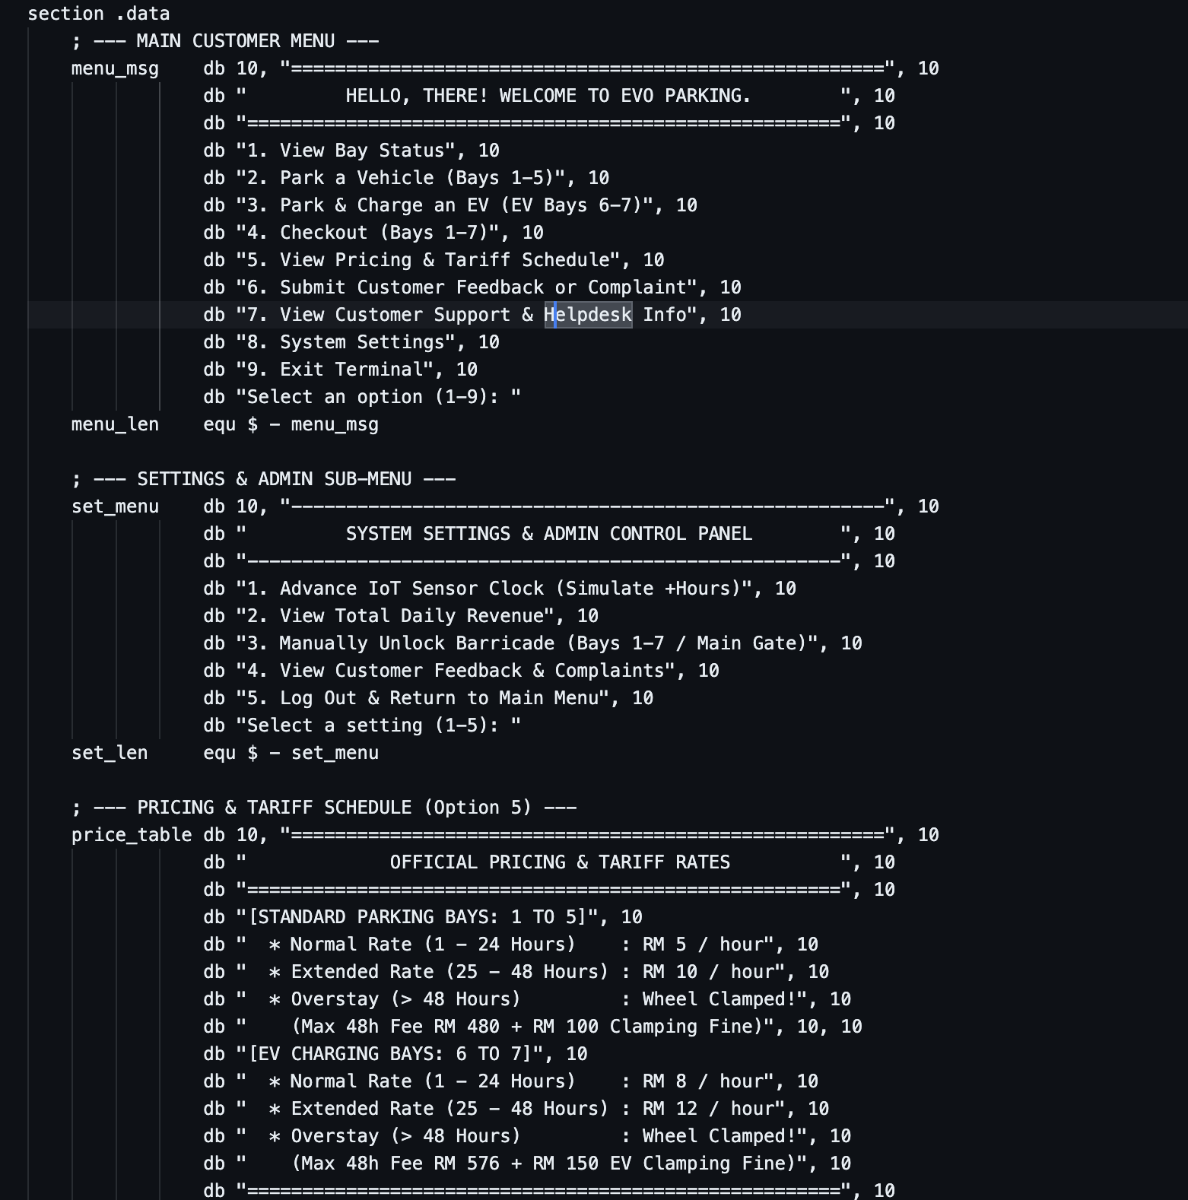
Detailed Explanation:
- section .data Directive: Declares the initialized read/write memory segment of the ELF32 binary.
- db (Define Byte) & ASCII Control Characters: Allocates contiguous sequences of 8-bit ASCII characters in memory. The integer 10 (0x0A) is embedded directly at the end of each line to represent the Linux newline character (\n), allowing multi-line menus (menu_msg, set_menu, and price_table) to be printed in a single kernel call.
- Dynamic String Length Calculation (equ $ - label): Rather than manually counting characters, the NASM equ directive calculates string byte lengths at assembly time by subtracting the starting memory address of the label (e.g., menu_msg) from the current assembler location counter ($).

5.2. Prompts, Receipt Templates & Admin Strings

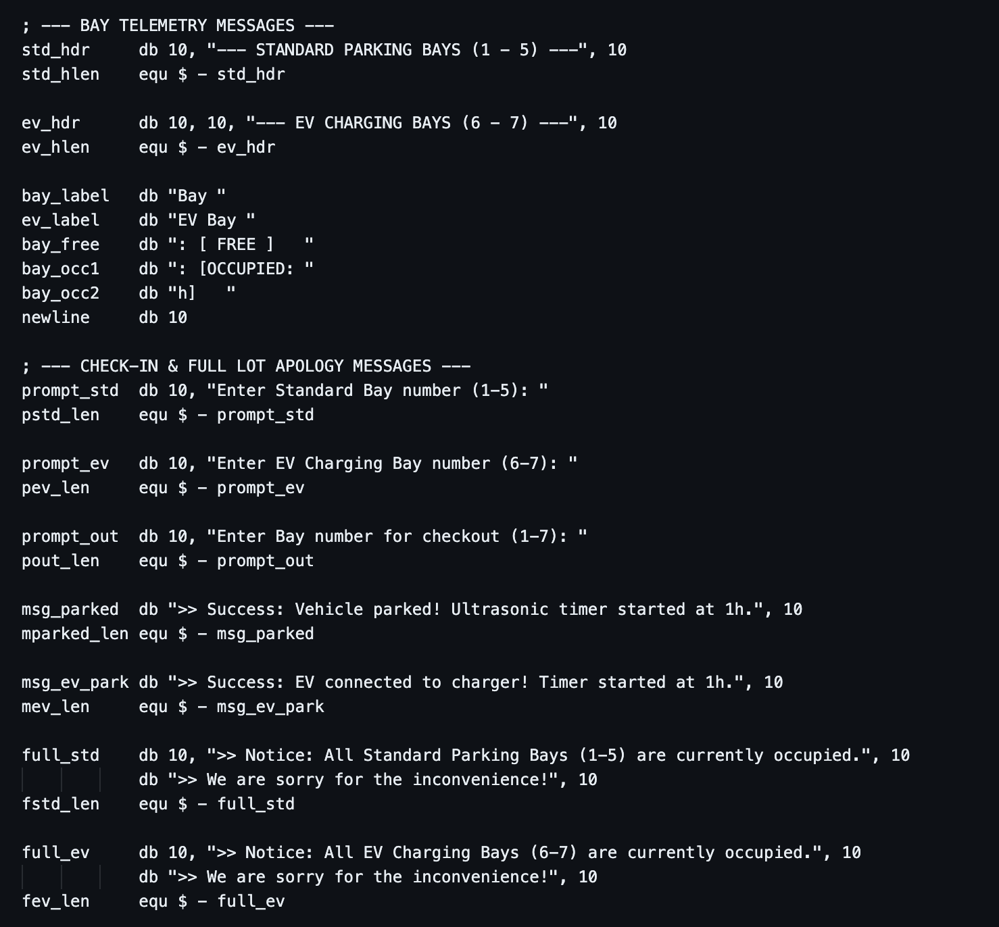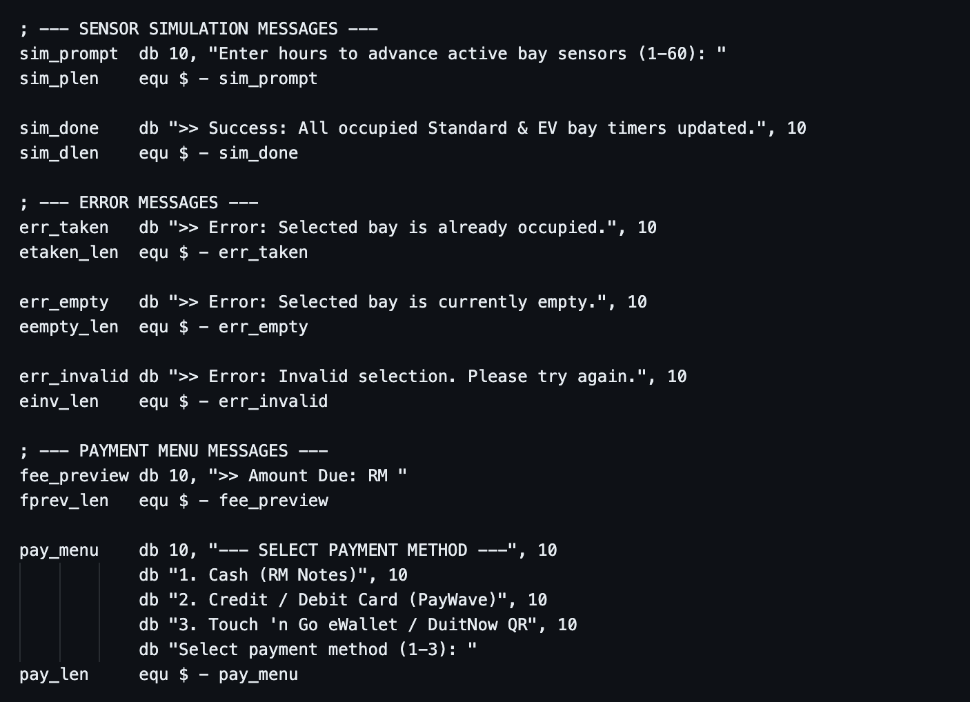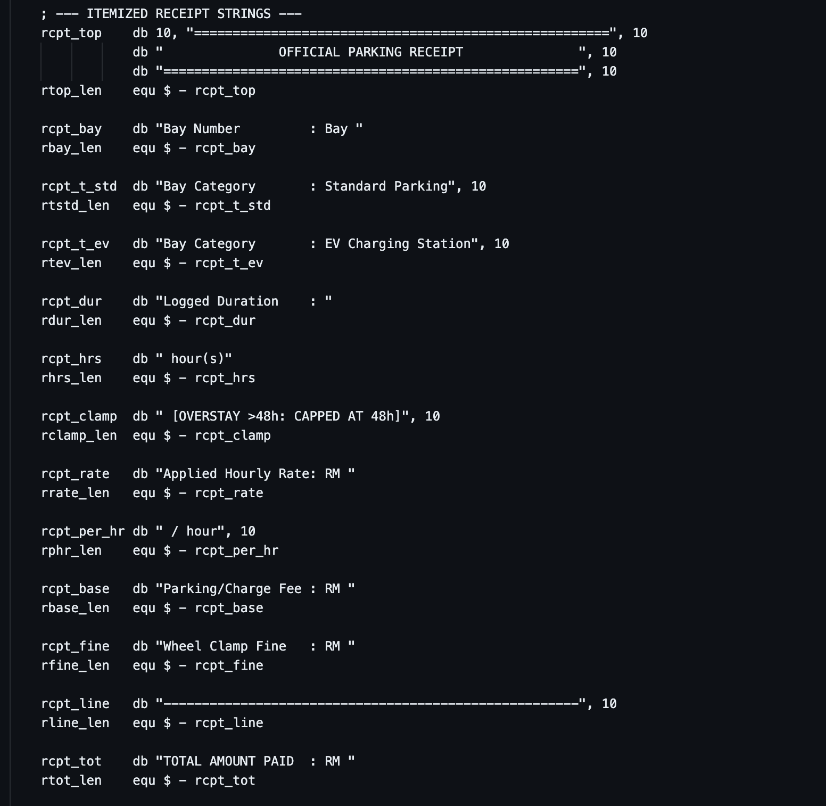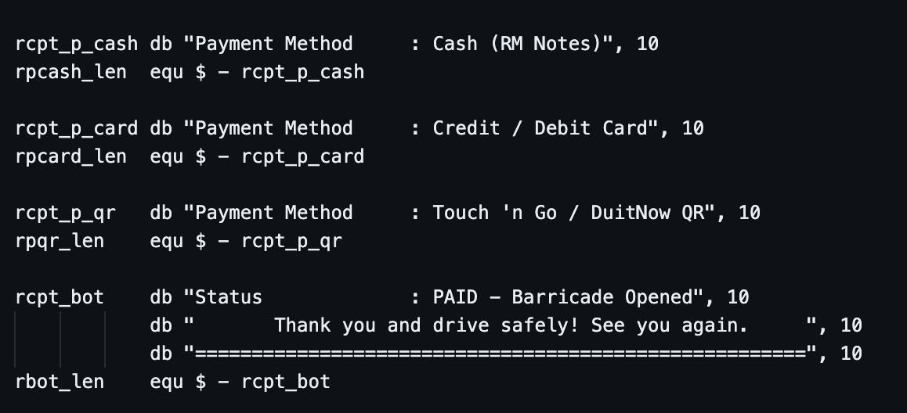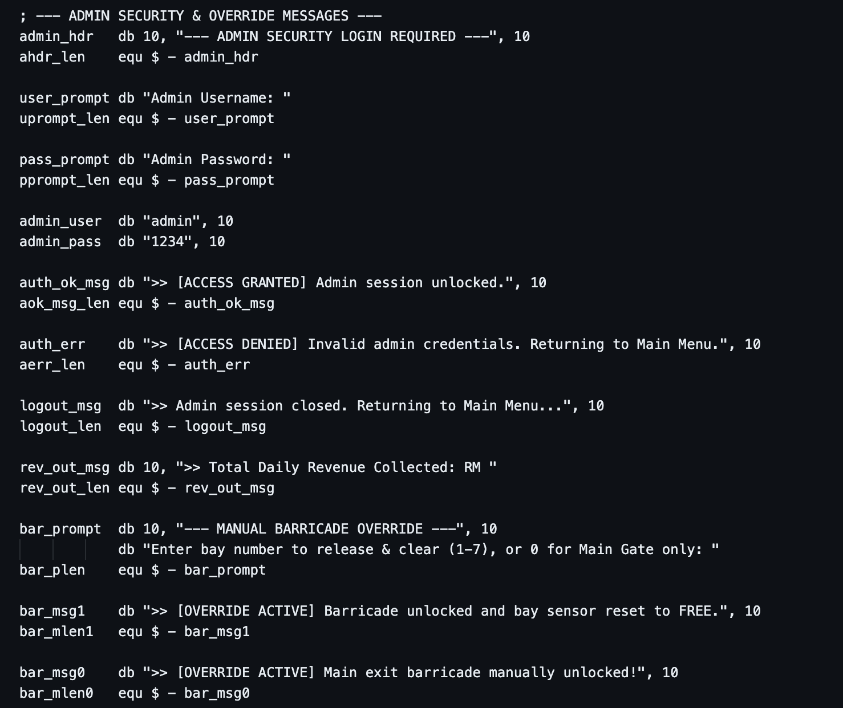
Detailed Explanation:
- Modular String Fragments for Telemetry & Receipts: Because assembly language does not have high-level string interpolation (like printf("Bay %d: [OCCUPIED: %dh]", bay, hrs)), strings are split into static prefixes (bay_occ1), dynamic integer print calls, and static suffixes (bay_occ2).
- Stored Authentication Credentials (admin_user & admin_pass): Stores the administrator username ("admin") and password ("1234") followed by 10 (\n). Including the newline byte 10 matches the raw input captured from the user's keyboard when they press ENTER during sys_read.

5.3. Hardware Sensor Arrays, State Variables & Uninitialized Buffers (.data & .bss)

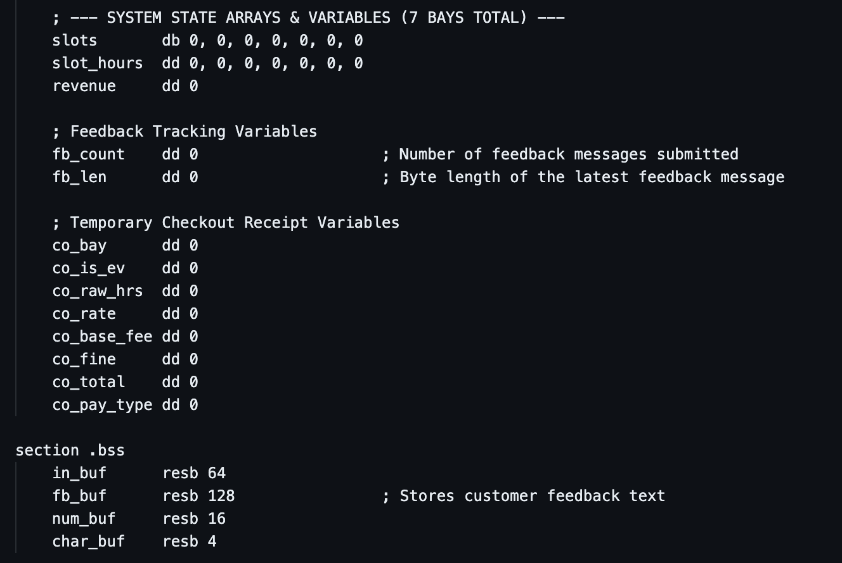

Detailed Explanation:
- Parallel Hardware Sensor Arrays (slots & slot_hours):
- slots is a 7-element byte array (db) initialized to 0, where each byte represents the binary state of an ultrasonic presence sensor (0 = Empty, 1 = Vehicle Present). Indices 0..4 represent Standard Bays 1–5; indices 5..6 represent EV Bays 6–7.
- slot_hours is a 7-element doubleword array (dd, 4 bytes per element = 32 bits) that tracks the accumulated hours for each bay.
- 32-Bit State & Receipt Variables (dd): Allocates 32-bit integers in memory for cumulative daily revenue (revenue), customer feedback tracking (fb_count, fb_len), and temporary checkout receipt fields (co_bay through co_pay_type).
- section .bss (Uninitialized Buffers): Uses resb (Reserve Byte) to allocate zero-initialized memory buffers for user keyboard input (in_buf, 64 bytes), customer complaint text (fb_buf, 128 bytes), multi-digit ASCII conversion (num_buf, 16 bytes), and single-character output (char_buf, 4 bytes).

5.4. Program Entry Point & Main Menu Dispatcher (_start & main_loop)

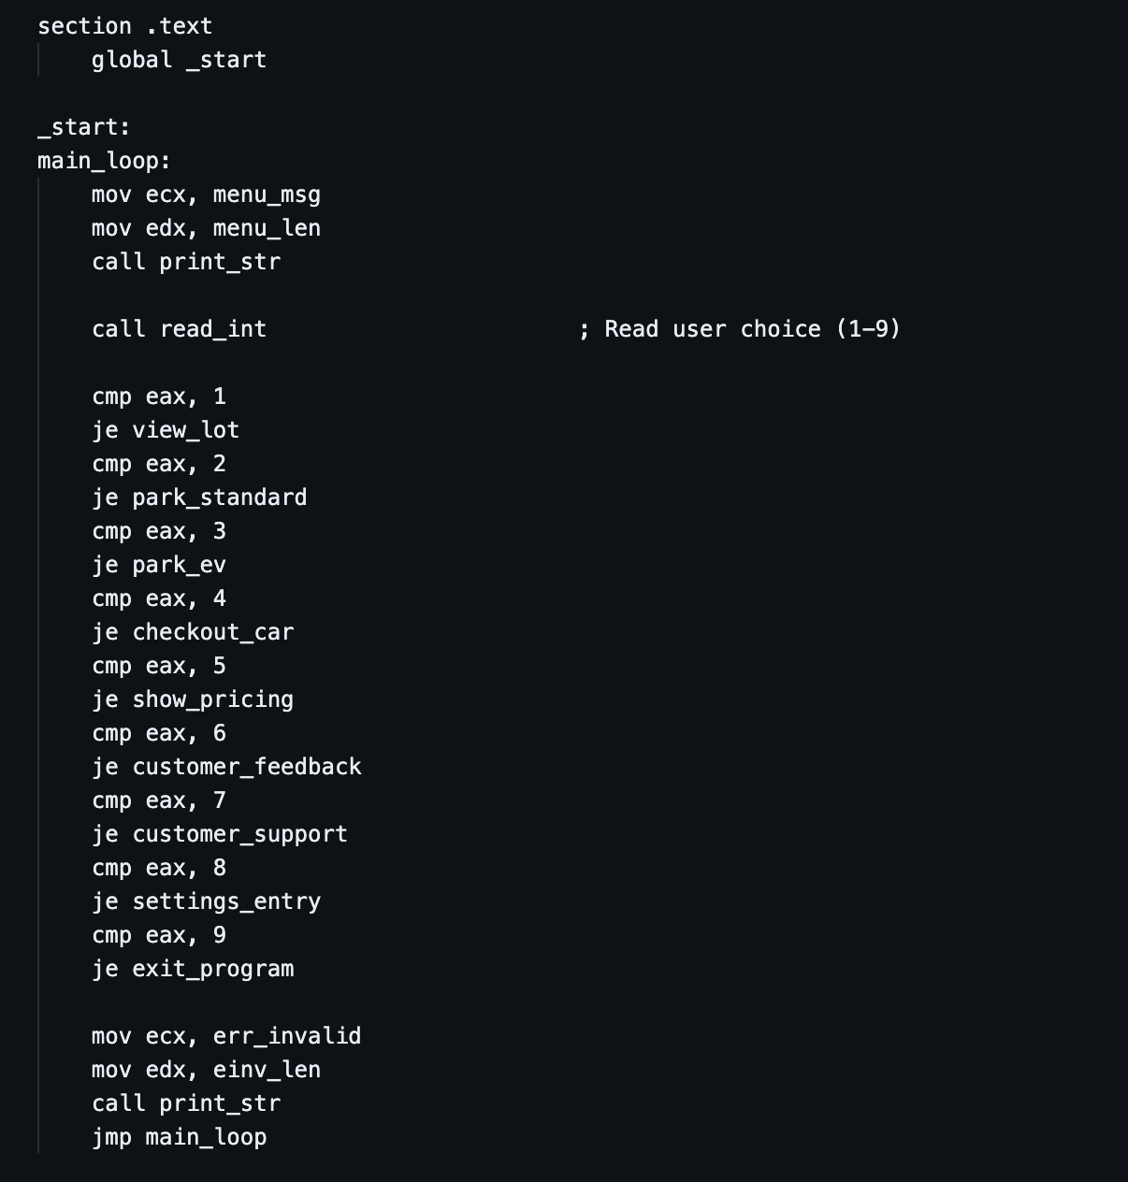

Detailed Explanation:
- section .text & global _start: Declares the executable code segment and exports the _start symbol so the GNU linker (ld) knows where program execution begins.
- Conditional Jump Dispatch Table (Requirement 3: Jumps): After call read_int parses the user's numeric input into register EAX, a sequence of CMP EAX, <value> instructions subtracts the immediate value from EAX to update the CPU Zero Flag (ZF). If ZF == 1, the corresponding JE (Jump if Equal) instruction branches execution to the selected module.
- Error Fallthrough & Unconditional Loop (JMP main_loop): If the user enters a number outside 1–9, execution falls through all JE checks, prints err_invalid, and executes an unconditional jump (JMP main_loop) to restart the menu cycle.

5.5. Live Bay Telemetry Loops
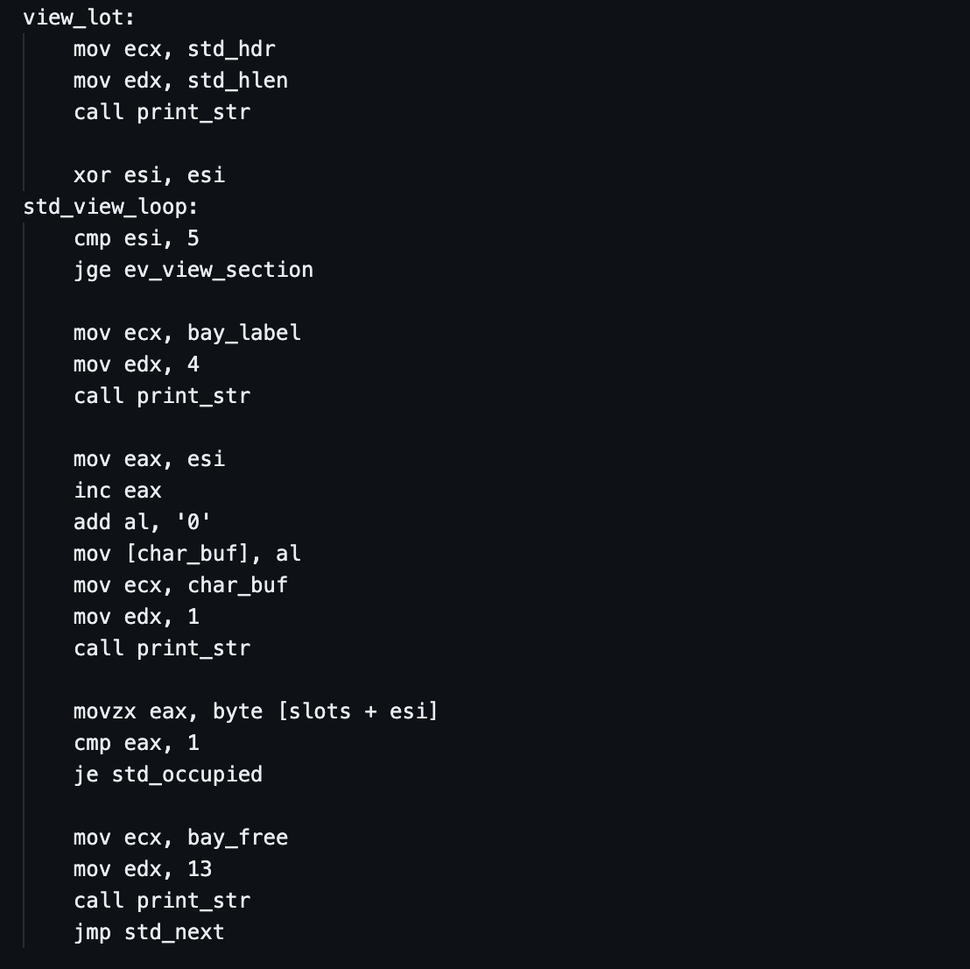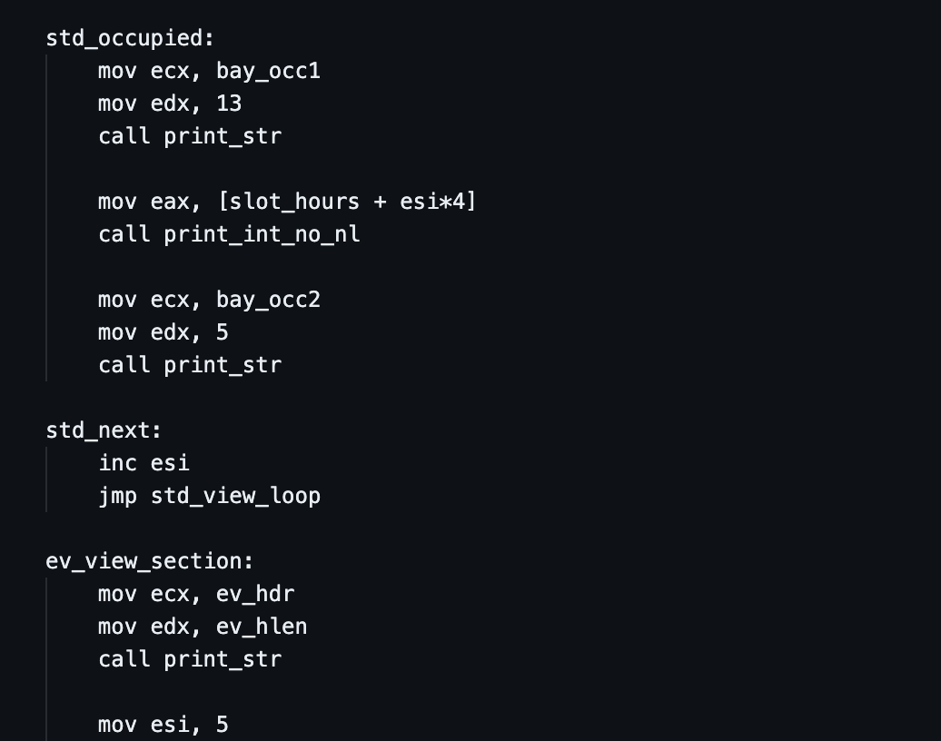
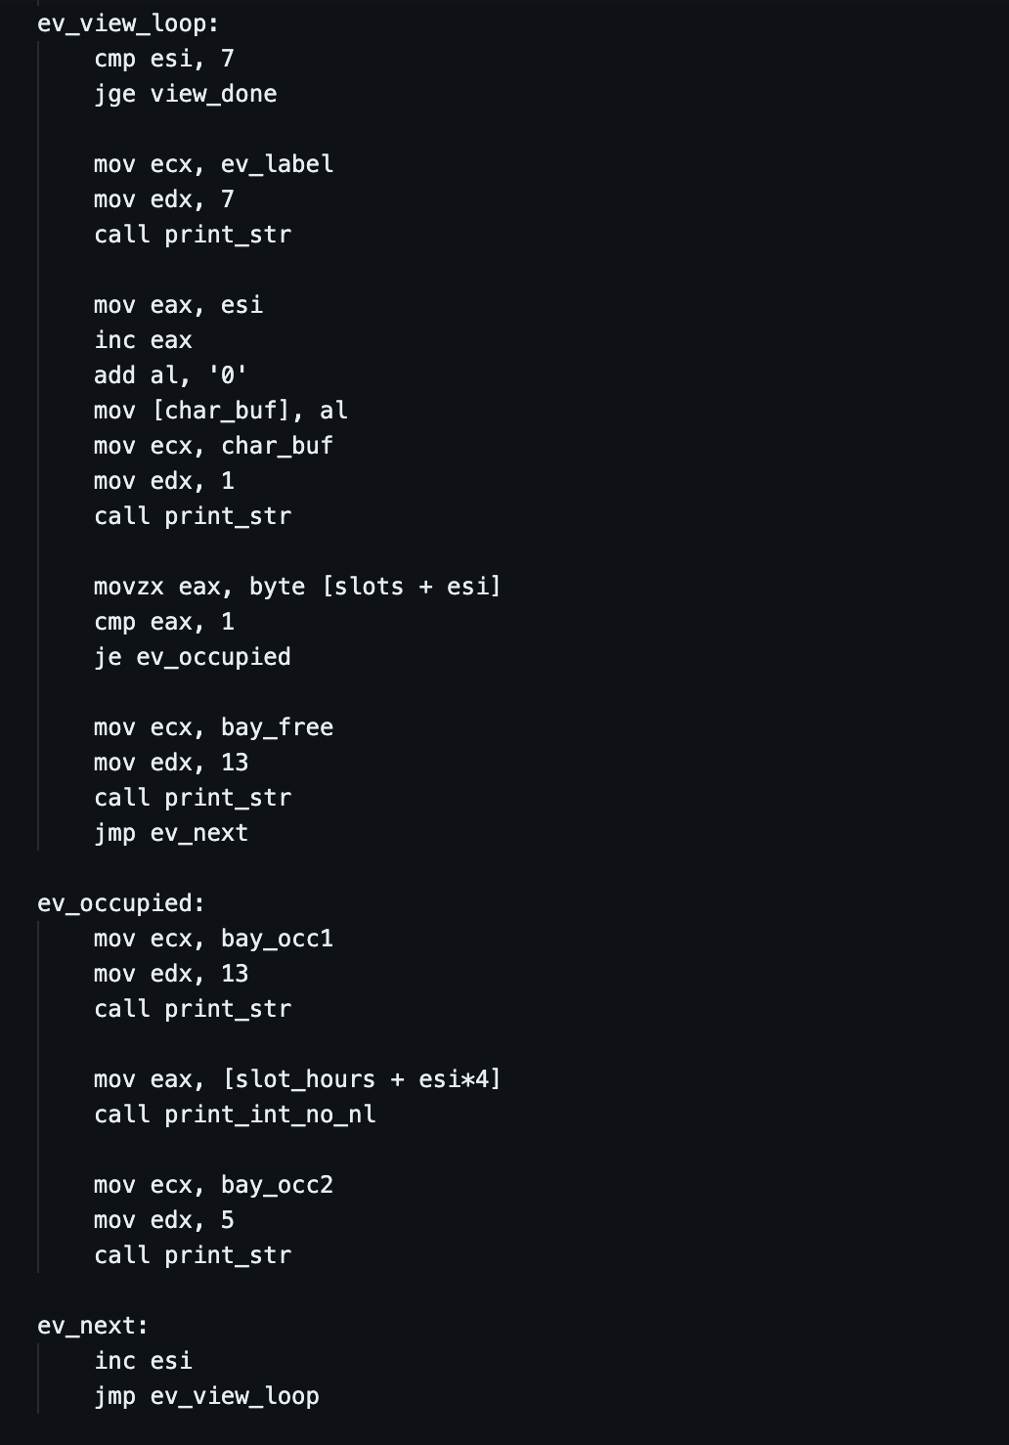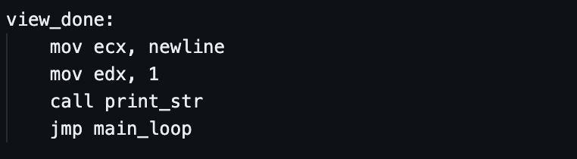
Detailed Explanation:
- Iterative Array Traversal (Requirement 3: Loops): Initializes index register ESI to 0 (XOR ESI, ESI) and loops through indices 0..4 for Standard Bays (std_view_loop), followed by indices 5..6 for EV Bays (ev_view_loop). At each iteration, CMP ESI, 5 and JGE (Jump if Greater or Equal) test the loop termination condition.
- Zero-Extended Byte Addressing (MOVZX) vs. Scaled-Index Addressing (esi*4):
- Because slots is an array of 1-byte elements (db), movzx eax, byte [slots + esi] reads a single byte at offset esi and zero-extends it into 32-bit EAX.
- Because slot_hours is an array of 4-byte doublewords (dd), mov eax, [slot_hours + esi*4] uses x86 scaled-index addressing (base + index * scale) to multiply ESI by 4 in hardware, fetching the exact 32-bit hour counter for that bay.

5.6. Pre-Check-In Full-Lot Scan & Vehicle Check-In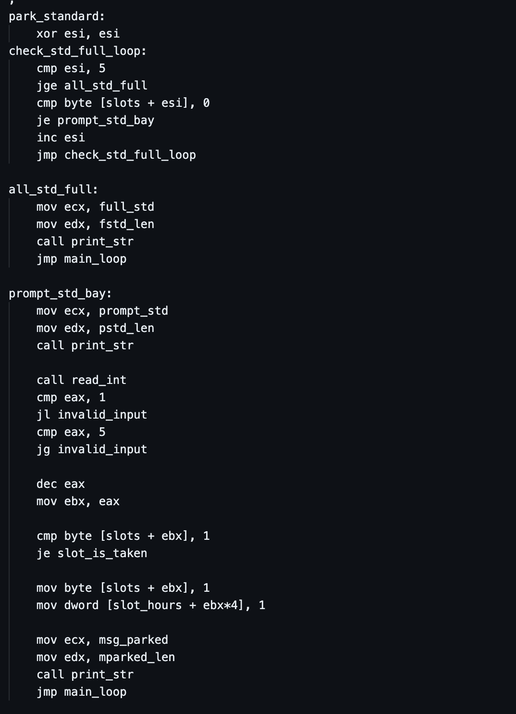
(Note: park_ev uses the identical pattern for ESI = 5 to 6 / EV Bays 6–7.)
Detailed Explanation:
- Automated Capacity Scan Loop (check_std_full_loop & check_ev_full_loop): Before prompting the user for a bay number, a linear search loop scans slots[0..4] (for Standard) or slots[5..6] (for EV). As soon as it finds a 0 (JE prompt_std_bay), it breaks out of the loop and allows the user to check in. If ESI reaches the upper bound without finding any 0 (JGE all_std_full), the lot is 100% full, and the terminal immediately displays the apology notice.
- Boundary Validation & Index Arithmetic (JL, JG, DEC): Uses signed conditional jumps (JL Jump if Less, JG Jump if Greater) to enforce bay boundaries (1–5 for Standard, 6–7 for EV), then decrements EAX (DEC EAX) to map the human-friendly bay number to a 0-based memory offset in EBX.

5.7. Checkout Validation & Multi-Tier Tariff Arithmetic
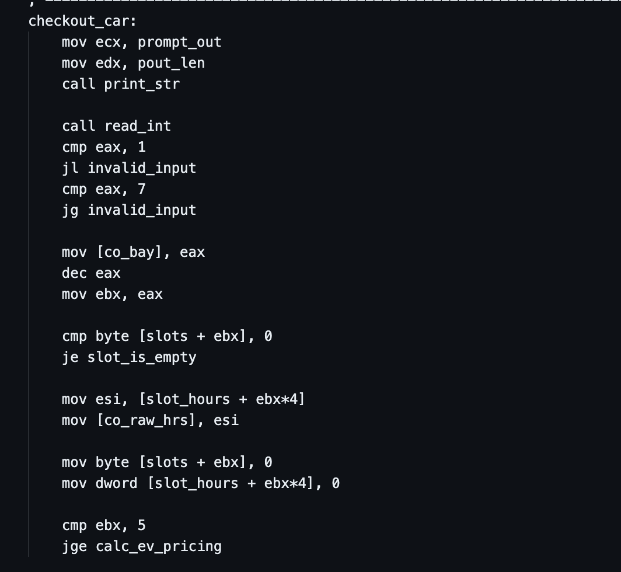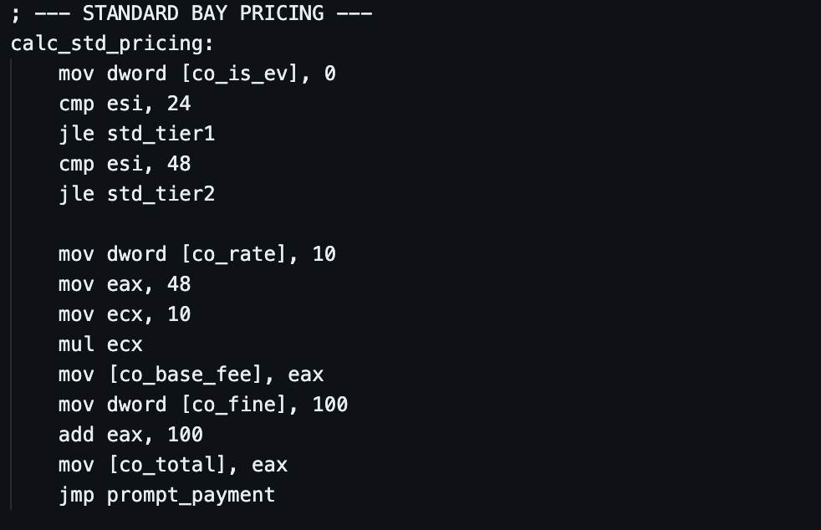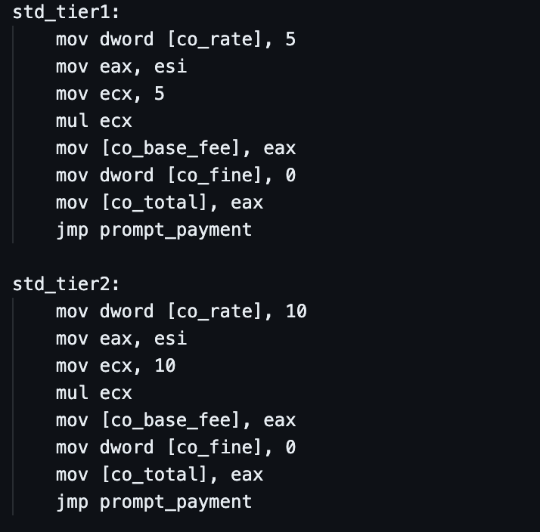

(Note: std_tier1, std_tier2, and calc_ev_pricing follow the exact same arithmetic structure for RM 5, RM 10, RM 8, RM 12, and the RM 150 EV Clamp Fine.)
Detailed Explanation:
- Automated Sensor Retrieval & Reset: Reads the vehicle's parked duration directly from [slot_hours + ebx*4] into ESI and immediately clears both slots[ebx] and slot_hours[ebx*4] to 0 so the bay is ready for the next customer.
- Category & Tier Branching (JGE, JLE): First checks CMP EBX, 5 (JGE calc_ev_pricing) to separate Standard Bays (0..4) from EV Charging Bays (5..6). Next, CMP ESI, 24 (JLE) and CMP ESI, 48 (JLE) route the duration into one of three pricing tiers: Normal (1–24h), Extended (25–48h), or Overstay Wheel-Clamped (>48h).
- Hardware Multiplication & Fine Addition (Requirement 3: Arithmetic): Uses unsigned multiplication (MUL ECX, which multiplies EAX by ECX and stores the product in EDX:EAX) to compute the base parking fee, and ADD EAX, 100 (or ADD EAX, 150 for EV) to add the wheel-clamping penalty. Every intermediate value (co_rate, co_base_fee, co_fine, co_total) is saved in memory for the receipt printer.

5.8. Payment Gateway & Itemized Official Receipt Generator

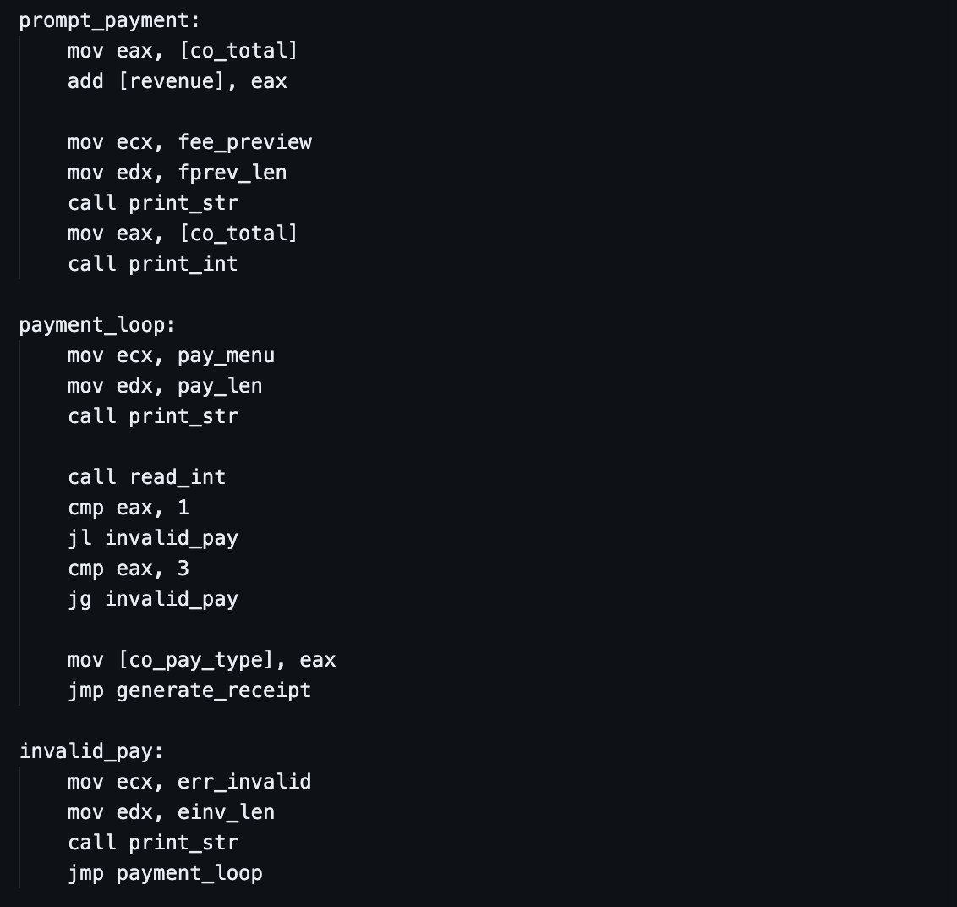
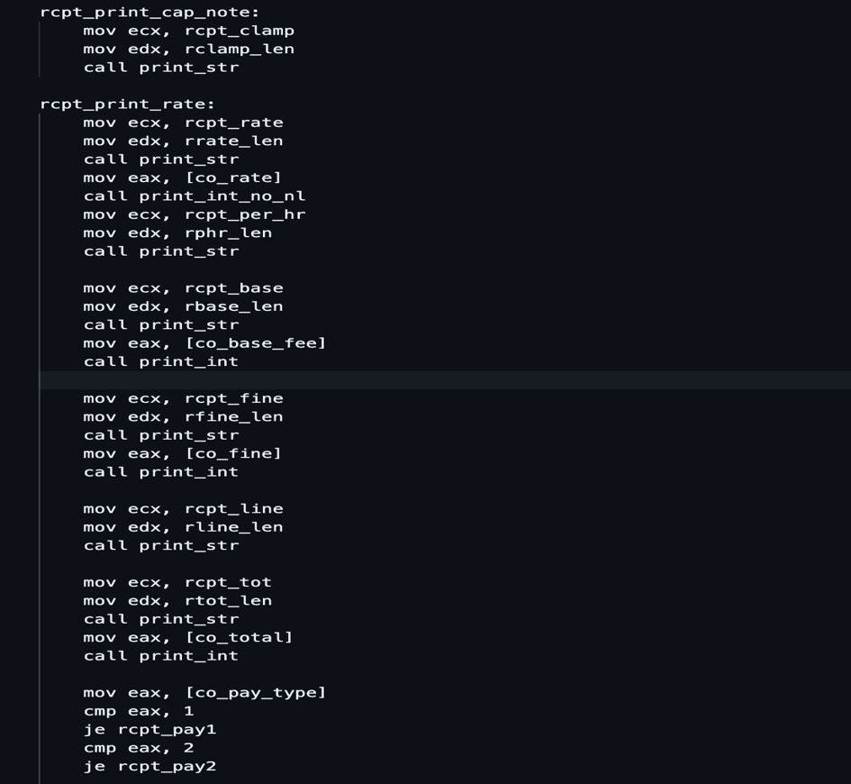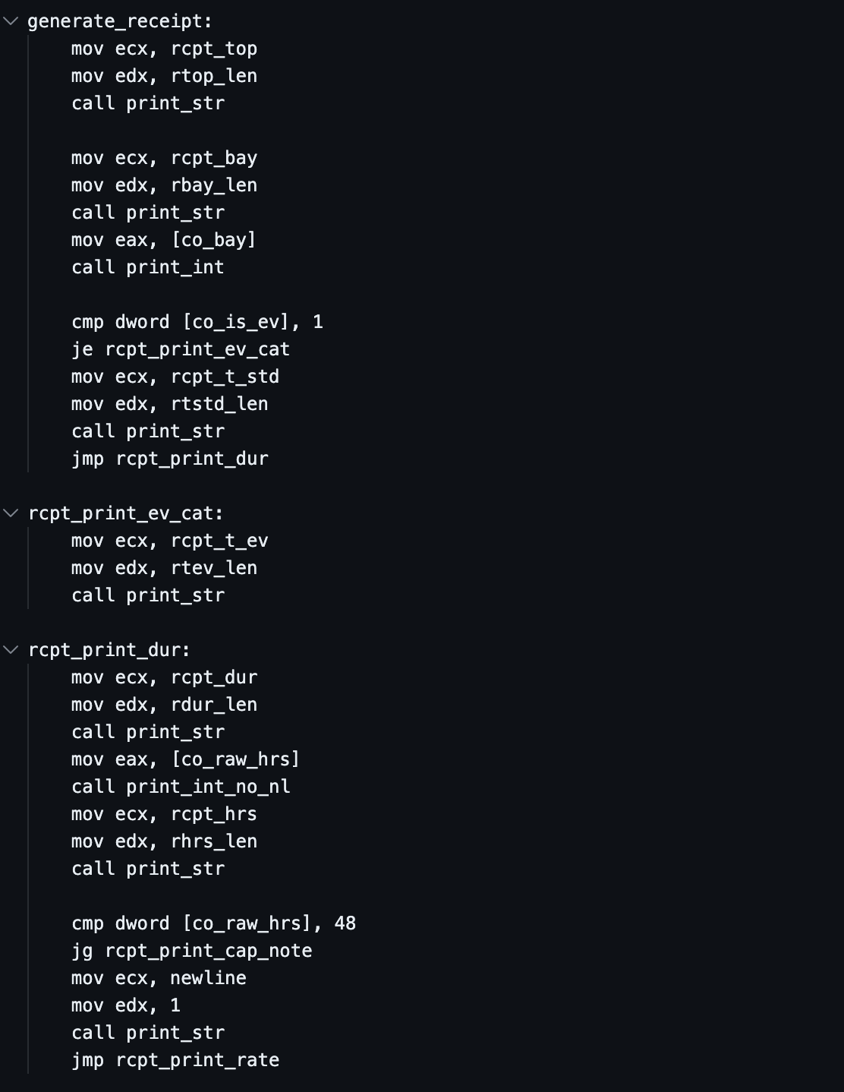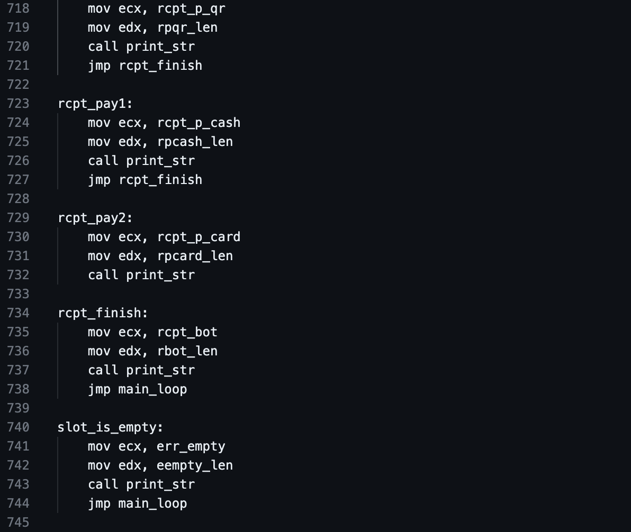
Detailed Explanation:
- Revenue Accumulation (ADD [revenue], EAX): Directly adds the 32-bit value in EAX (co_total) into the memory variable [revenue], maintaining an accurate running total across all transactions.
- Input-Validated Payment Sub-Loop (payment_loop): Traps the user in a validation loop until they select a valid payment method (1 = Cash, 2 = Card, 3 = Touch 'n Go / DuitNow QR).
- Conditional Receipt Formatting (generate_receipt): Sequentially prints each receipt row, using conditional jumps (CMP dword [co_is_ev], 1, CMP dword [co_raw_hrs], 48, and CMP EAX, 1..3) to dynamically insert the correct bay category, [OVERSTAY >48h: CAPPED AT 48h] warning badge, and chosen payment method string.

5.9. Tariff Display, Customer Feedback Logger & Support Info

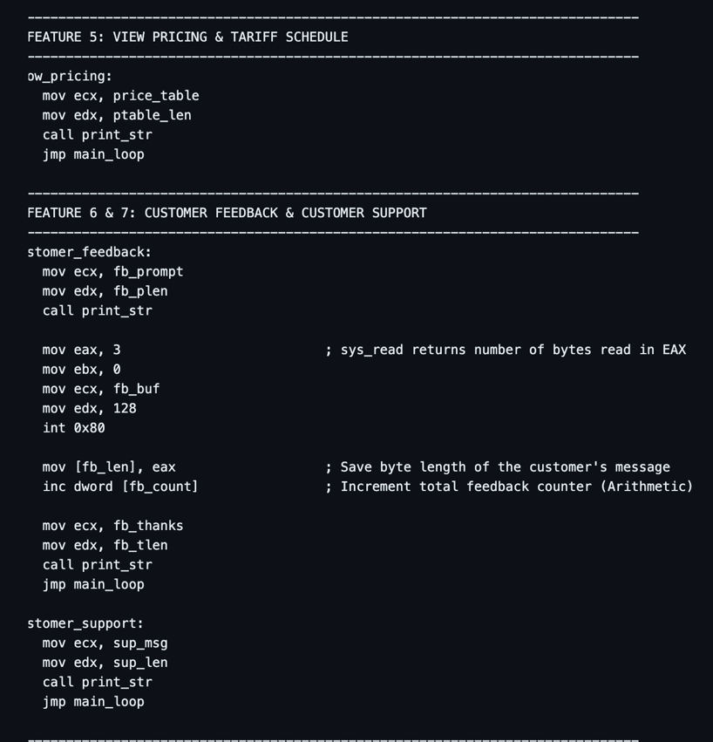
Detailed Explanation:
- Capturing Free-Text Input via Kernel Return Value (sys_read): When int 0x80 executes with EAX = 3 (sys_read), the Linux kernel reads up to 128 characters from the keyboard into fb_buf and returns the exact number of bytes read inside register EAX.
- Saving State for Admin Review (MOV [fb_len], EAX & INC dword [fb_count]): Saving EAX into [fb_len] allows the Admin Feedback Viewer to print the exact length of the customer's message later without printing trailing garbage bytes, while INC dword [fb_count] performs a memory-direct increment to count total daily submissions.

5.10. Session-Based Admin Settings & IoT Sensor Clock Simulator

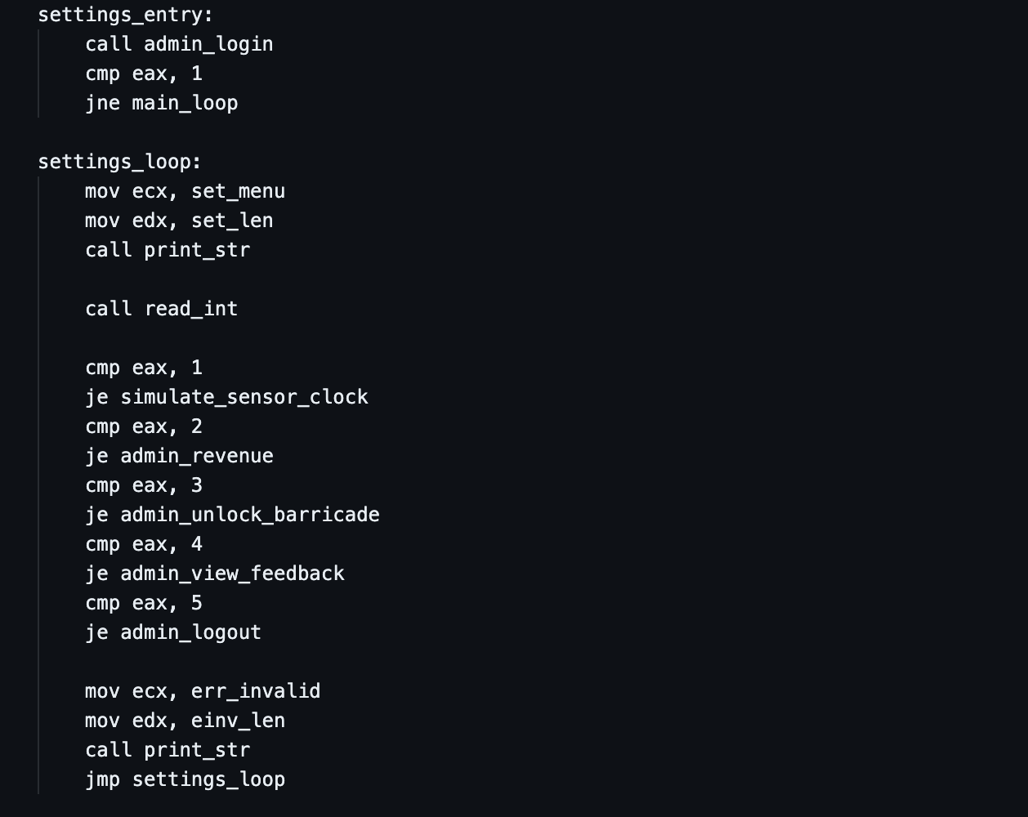
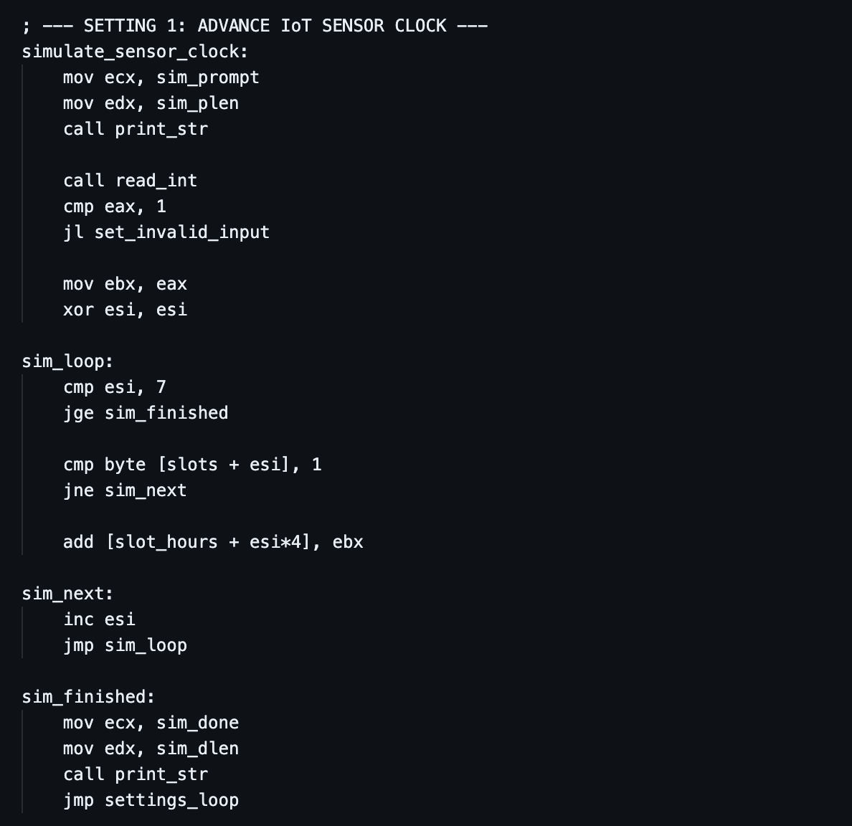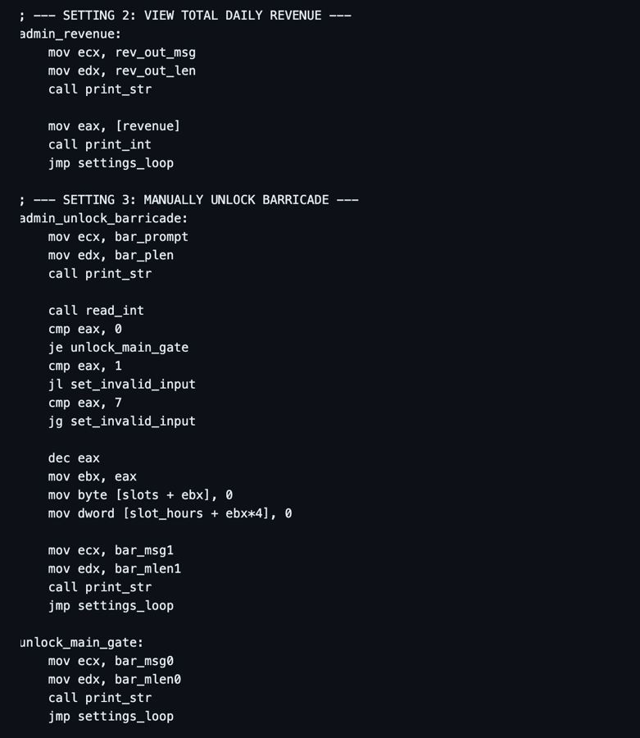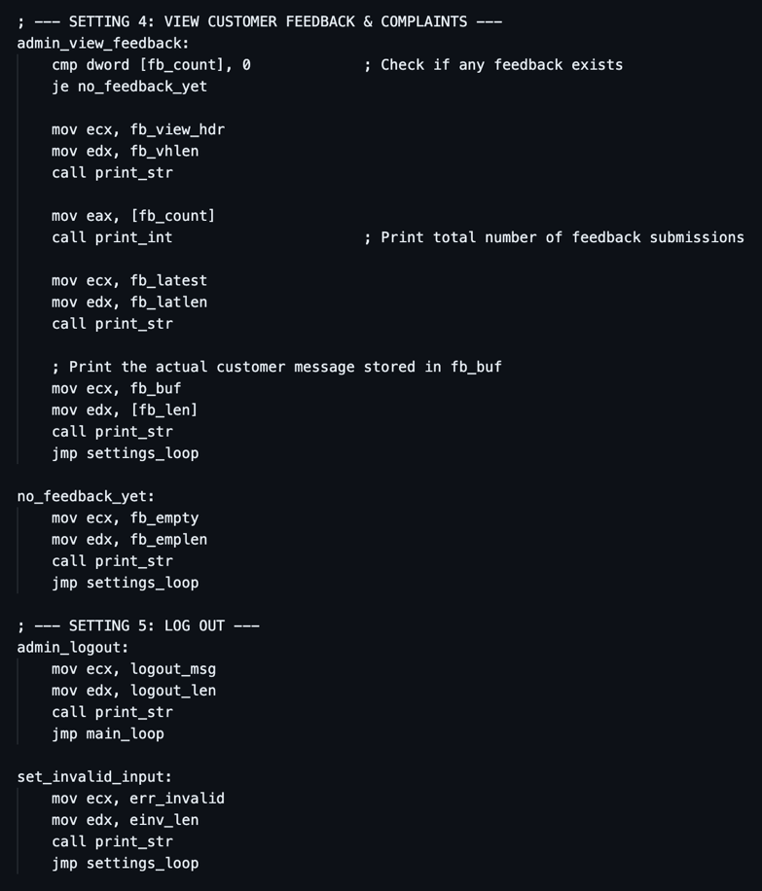
Detailed Explanation:
- Session-Based Authentication Gate (settings_entry vs. settings_loop): Calling admin_login at settings_entry verifies the administrator's credentials once. Once inside settings_loop, all admin operations branch back to settings_loop rather than settings_entry, maintaining an authenticated session until Option 5 (admin_logout) is chosen.
- Selective Array Accumulation (sim_loop): Iterates through all 7 bays (ESI = 0 to 6), inspects CMP byte [slots + esi], 1, and uses JNE sim_next to skip empty bays. For occupied bays, ADD [slot_hours + esi*4], EBX adds the simulated hours directly into the 32-bit timer array in memory.
- Emergency Hardware Override (admin_unlock_barricade): Allows the administrator to either open the main exit gate (EAX == 0) or force-release any specific bay (1–7) by zeroing slots[ebx] and slot_hours[ebx*4] without adding to [revenue].
- Feedback Log Retrieval (admin_view_feedback): Checks CMP dword [fb_count], 0 (JE no_feedback_yet). If messages exist, it prints the total count followed by the raw customer string in fb_buf using the saved byte count [fb_len]

5.11. Clean System Termination & Subroutines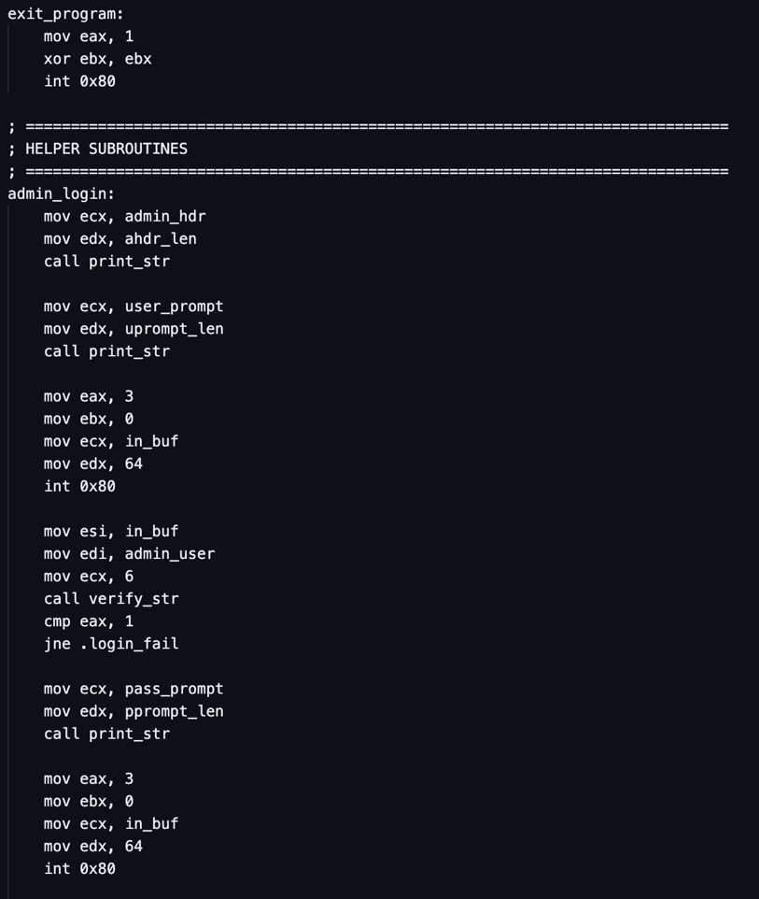
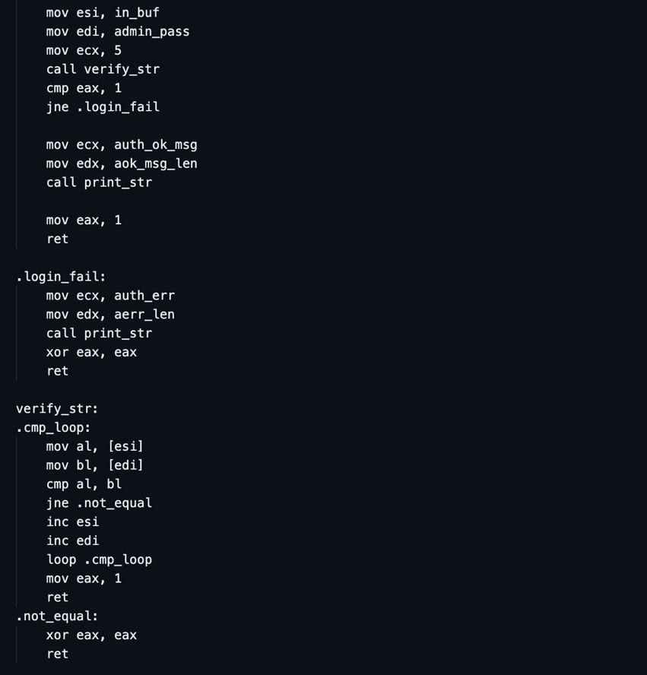 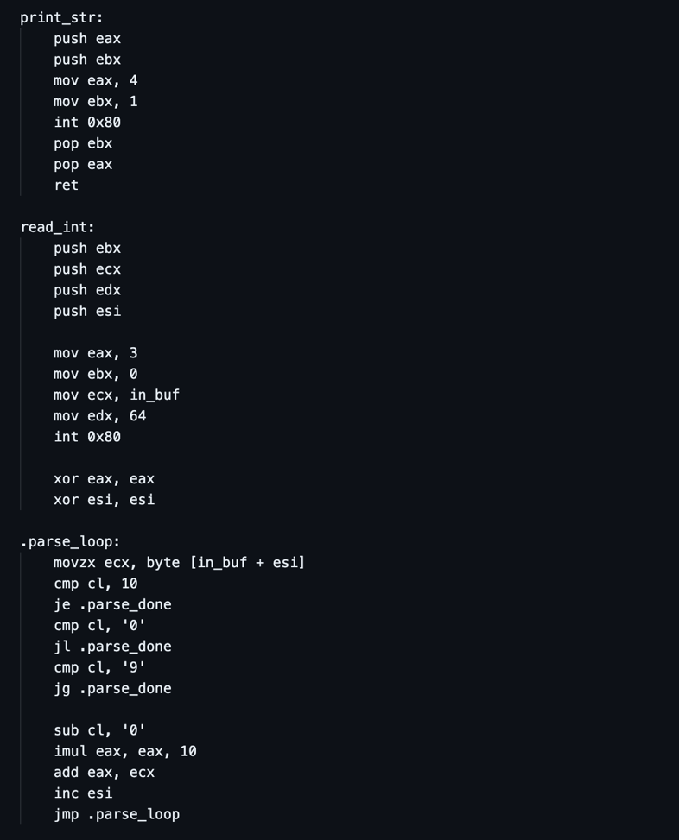 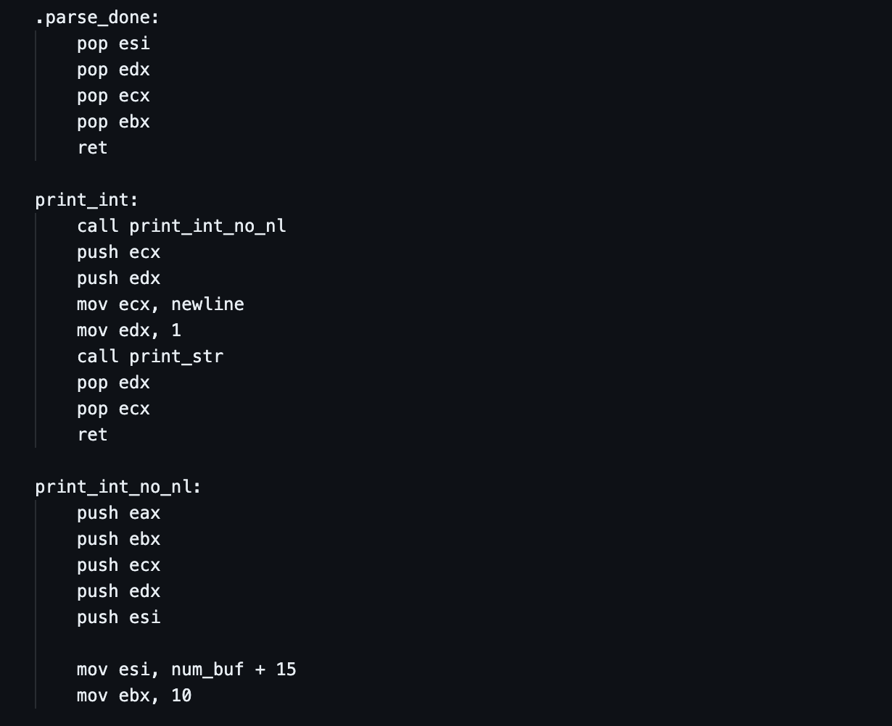 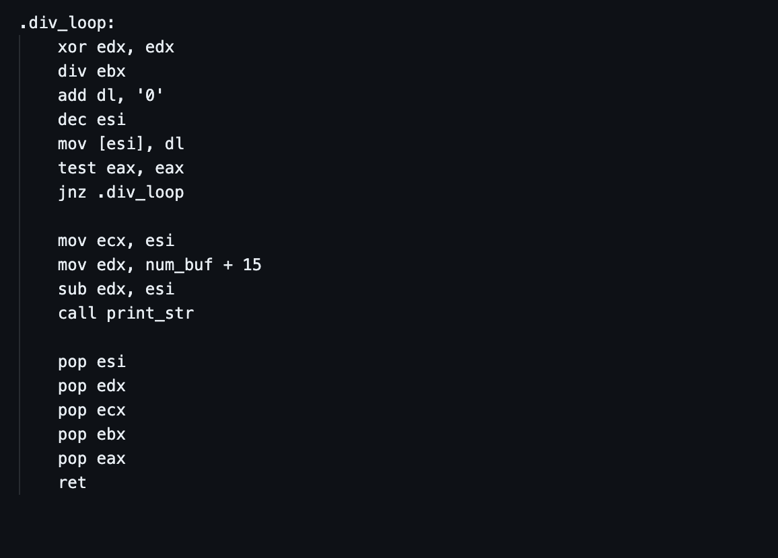
Detailed Explanation:
- Hardware-Counted String Comparison (verify_str & LOOP): Places the user input pointer in ESI, the expected credential pointer in EDI, and the exact byte length in ECX. Inside .cmp_loop, AL and BL load one character byte from each string and compare them (CMP AL, BL). If any byte differs, JNE .not_equal immediately aborts and returns EAX = 0. Otherwise, ESI and EDI advance (INC), and the x86 LOOP instruction automatically decrements ECX and branches back to .cmp_loop until ECX == 0, returning EAX = 1.
- Stack Preservation (PUSH & POP): Both print_str and read_int push working registers onto the processor stack (ESP) at the start of the subroutine and pop them in reverse (LIFO) order before RET. This guarantees that calling I/O subroutines never corrupts loop counters or arithmetic values in the calling module.
- Horner's Method Base-10 Parsing (.parse_loop): Converts an arbitrary-length string of ASCII digits (e.g., "50\n") into a 32-bit binary integer in EAX. For each character between '0' (48) and '9' (57), it subtracts '0' (SUB CL, '0'), multiplies the running total by 10 (IMUL EAX, EAX, 10), and adds the new digit (ADD EAX, ECX).
- 32-Bit Hardware Division (XOR EDX, EDX & DIV EBX): In 32-bit x86 assembly, DIV EBX divides the 64-bit value across EDX:EAX by EBX (10). Clearing EDX (XOR EDX, EDX) before every division prevents a Floating Point Exception (SIGFPE) divide overflow. After DIV EBX executes, the quotient is stored in EAX and the rightmost base-10 digit (remainder 0–9) is stored in EDX (DL).
- Reverse Buffer Construction & Pointer Subtraction: Because division extracts the ones digit first, then tens, then hundreds, the pointer ESI starts at the end of the buffer (num_buf + 15) and decrements (DEC ESI) on each iteration of .div_loop. Once the quotient reaches 0 (TEST EAX, EAX / JNZ .div_loop), subtracting the final pointer ESI from num_buf + 15 (SUB EDX, ESI) yields the exact byte length of the number for print_str.

6.0 CONCLUSION
The design and implementation of the Smart Parking & EV Charging Terminal (v5.1) successfully demonstrates how 32-bit x86 assembly language (NASM on Linux) can be structured to build a feature-complete, hardware-oriented embedded terminal application. By organizing the system around compact byte and doubleword arrays (slots and slot_hours) and reusable ASCII-to-integer conversion subroutines (read_int and print_int_no_nl), the program avoids memory corruption pitfalls while delivering a responsive user interface.
Furthermore, the project fulfills every core technical requirement of the specification:
- Arithmetic Operations: Executed via multi-tier tariff multiplications (MUL), clamping fine and revenue additions (ADD), array index calculations (INC, DEC), and base-10 integer conversions (IMUL, DIV).
- Iterative Loops: Implemented across real-time sensor telemetry displays, pre-check-in full-lot capacity scans, IoT sensor clock advances, and hardware-counted string authentication (LOOP).
- Conditional and Unconditional Jumps: Used to enforce input boundary checks, differentiate between Standard and EV pricing tiers, verify administrator credentials, and maintain nested session loops.
Ultimately, this project illustrates why assembly language remains foundational across both embedded hardware engineering and cybersecurity reverse engineering—providing unmatched execution transparency, deterministic control, and zero-abstraction efficiency.

7.0 REFERENCES
- Carter, P. A. (2019). PC Assembly Language. GitHub Pages / Self-Published.
- Duntemann, J. (2023). Assembly Language Step-by-Step: Programming with Linux (4th ed.). Wiley.
- Eagle, C. (2020). The IDA Pro Book: The Unofficial Guide to the World's Most Popular Disassembler (2nd ed.). No Starch Press.
- Intel Corporation. (2024). Intel 64 and IA-32 Architectures Software Developer’s Manual, Volume 1: Basic Architecture. Intel Press.
- Irvine, K. R. (2020). Assembly Language for x86 Processors (8th ed.). Pearson.
- Sikorski, M., & Honig, A. (2012). Practical Malware Analysis: The Hands-On Guide to Dissecting Malicious Software. No Starch Press.
- The NASM Development Team. (2024). NASM – The Netwide Assembler Documentation (Version 2.16). Retrieved from https://www.nasm.us/docs.php

8.0 APPENDICES

Appendix A: 32-Bit x86 Register Allocation Map
Register | 8-Bit / 16-Bit Sub-Registers | Primary Role in parking.asm
EAX | AX, AH, AL | Holds Linux syscall numbers (1, 3, 4), return values from read_int and verify_str, and serves as the primary operand for MUL and DIV.
EBX | BX, BH, BL | Holds file descriptors (0 = stdin, 1 = stdout), 0-based bay array index (0–6), and divisor 10 in print_int_no_nl.
ECX | CX, CH, CL | Holds string buffer pointers for sys_read/sys_write, multiplier rates (5, 8, 10, 12), and hardware loop counter in verify_str.
EDX | DX, DH, DL | Holds string lengths for sys_read/sys_write and stores modulo remainder (DL) during DIV in print_int_no_nl.
ESI | SI | Serves as loop index counter (0–6) for bay array scans, holds logged sensor hours during checkout, and points to source buffer in verify_str.
EDI | DI | Points to target credential string (admin_user, admin_pass) during verify_str.
ESP | SP | Hardware Stack Pointer; preserves register state across subroutine calls (PUSH / POP / CALL / RET).

Appendix B: Environment Setup and Compilation Guide (Linux / GitHub Codespaces)
To compile and run this 32-bit x86 NASM project on an Ubuntu Linux environment or GitHub Codespaces:
- Install NASM and GNU Binutils (if not installed prior):
sudo apt update && sudo apt install -y nasm binutils
- Assemble the Source File into a 32-Bit ELF Object File:
nasm -f elf32 parking.asm -o parking.o
- Link the Object File into an elf_i386 32-Bit Executable Binary:
ld -m elf_i386 parking.o -o parking
- Run the Executable:
./parking

Appendix C: Softcopy User Manual & Step-by-Step Operation Guide

C.1 Overview of the Terminal Interface
The EVO Parking (Smart Parking & EV Charging Terminal) operates via a numeric keypad command-line interface. Users interact with the terminal by typing the number corresponding to their desired menu option (1–9 on the Main Menu, 1–3 on the Payment Menu, or 1–5 on the Admin Control Panel) followed by pressing the ENTER key.
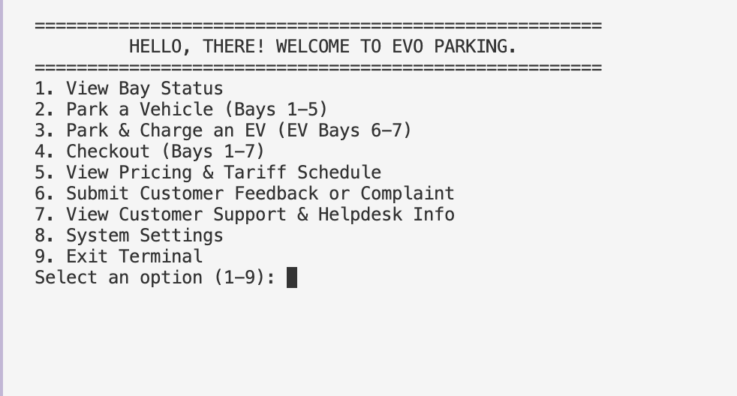

C.2 Driver Operation Guide (Standard & EV Customers)

1. Checking Available Parking & EV Charging Bays
- From the Main Menu, type 1 (View Bay Status) and press ENTER.
- The screen displays two sections: Standard Parking Bays (1 – 5) and EV Charging Bays (6 – 7).
- Bays marked [ FREE ] are open for parking. Bays marked [OCCUPIED: Xh] currently contain a vehicle and display the number of hours parked.
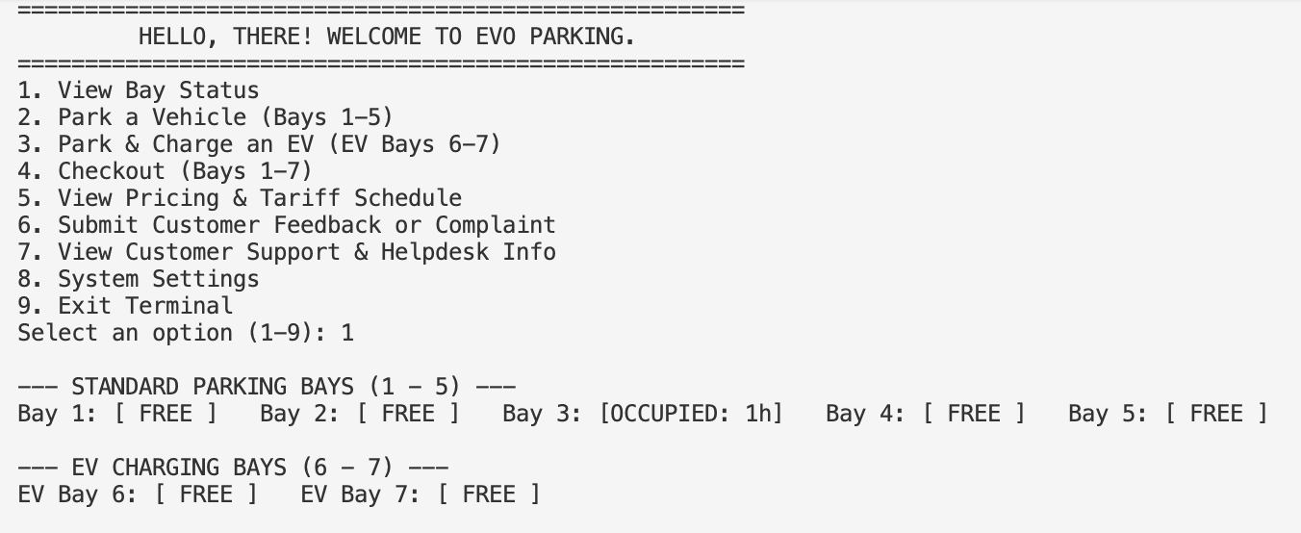

2. Parking a Standard Vehicle (Bays 1 – 5)
- From the Main Menu, type 2 (Park a Vehicle (Bays 1-5)) and press ENTER.
- Note: If all 5 standard bays are currently occupied, the system will automatically display an apology notice and return to the Main Menu.
- When prompted (Enter Standard Bay number (1-5):), type an available bay number between 1 and 5 and press ENTER.
- The ultrasonic bay sensor activates and starts your parking timer at 1h

.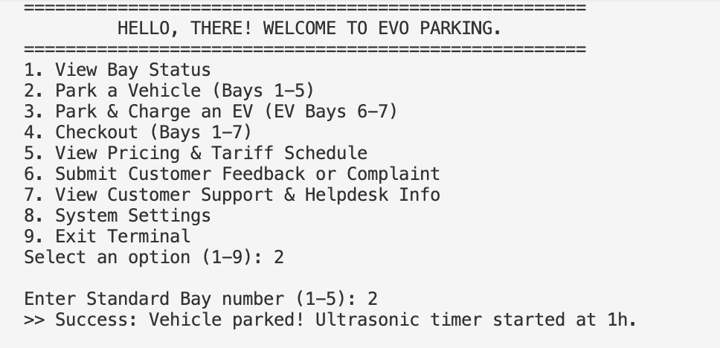

3. Parking & Charging an Electric Vehicle (EV Bays 6 – 7)
- From the Main Menu, type 3 (Park & Charge an EV (EV Bays 6-7)) and press ENTER.
- Note: If both EV bays are full, the terminal will notify you immediately.
- When prompted (Enter EV Charging Bay number (6-7):), type 6 or 7 and press ENTER.
- Connect your vehicle to the charger; the charging timer starts at 1h.

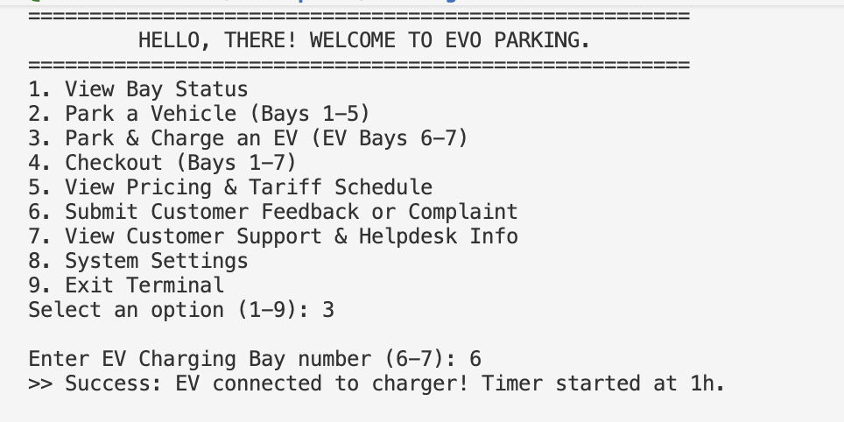

4. Checking Out, Paying & Printing an Official Receipt
- From the Main Menu, type 4 (Checkout (Bays 1-7)) and press ENTER.
- Enter your bay number (1 to 7) and press ENTER.
- The terminal automatically reads your parked hours from the bay sensor, calculates your tariff (and any overstay clamping fine if parked over 48 hours), and displays your Amount Due: RM X.
- At the SELECT PAYMENT METHOD menu, choose how you wish to pay:
- Type 1 for Cash (RM Notes)
- Type 2 for Credit / Debit Card (PayWave)
- Type 3 for Touch 'n Go eWallet / DuitNow QR
- Press ENTER. The terminal prints your Official Parking Receipt, resets the bay sensor to [ FREE ], and opens the exit barricade.

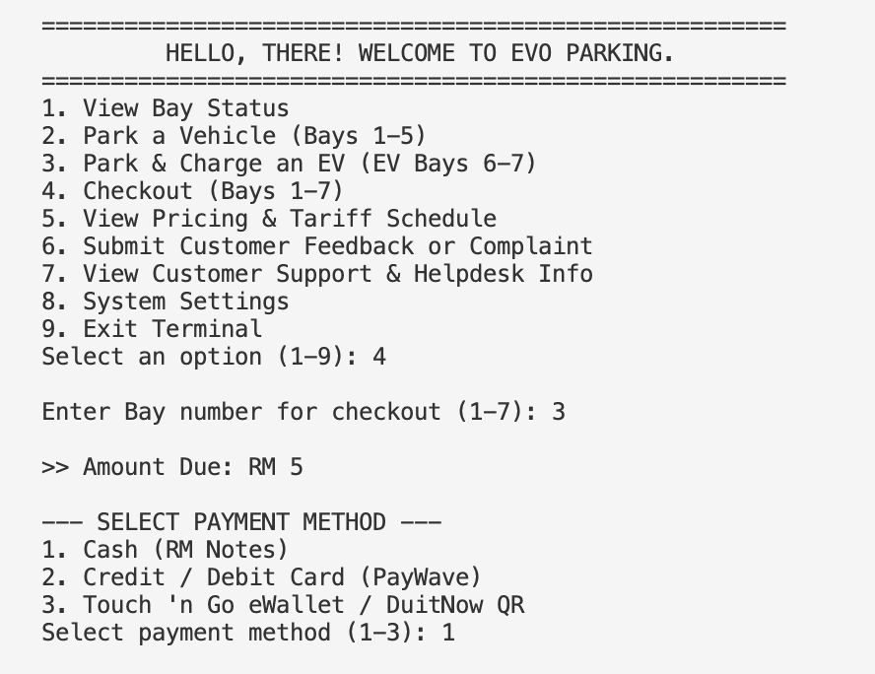

5. Viewing Tariff Rates, Submitting Feedback & Contacting Support
- To View Pricing & Clamping Rules: Type 5 at the Main Menu and press ENTER to view Normal (1–24h), Extended (25–48h), and Overstay Clamping (>48h) rates for Standard and EV bays.
- To Submit a Complaint or Feedback: Type 6 at the Main Menu, press ENTER, type your message (up to 128 characters), and press ENTER to log it for management review.
- To Contact 24/7 Helpdesk / Unclamping Unit: Type 7 at the Main Menu and press ENTER to view the hotline number (1-800-88-PARK), WhatsApp contact, and office location.

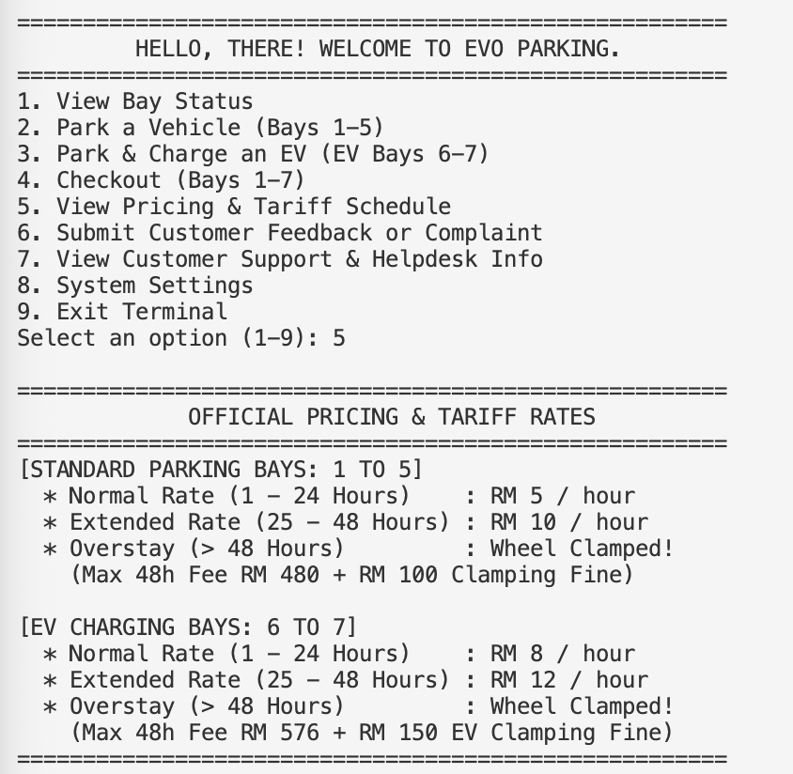

C.3 Administrator Operation Guide (Management & Security Controls)

1. Logging into the System Settings & Admin Control Panel
- From the Main Menu, type 8 (System Settings) and press ENTER.
- At Admin Username:, type admin (lowercase) and press ENTER.
- At Admin Password:, type 1234 and press ENTER.
- Once >> [ACCESS GRANTED] Admin session unlocked. appears, you remain logged in until you choose Option 5 to log out.

2. Advancing the IoT Sensor Clock (Simulating Time Passing)
- Inside the Admin Control Panel, type 1 (Advance IoT Sensor Clock (Simulate +Hours)) and press ENTER.
- Enter the number of hours you wish to fast-forward (e.g., 10, 30, or 50) and press ENTER.
- All currently occupied Standard and EV bays will have their timers incremented by that exact number of hours (empty bays remain at 0h).

3. Viewing Total Daily Revenue
- Inside the Admin Control Panel, type 2 (View Total Daily Revenue) and press ENTER.
- The system displays the cumulative RM collected from all completed checkouts during the session.

4. Manually Unlocking the Barricade (Emergency / VIP Override)
- Inside the Admin Control Panel, type 3 (Manually Unlock Barricade (Bays 1-7 / Main Gate)) and press ENTER.
- Choose your override target:
- Type 0 to unlock the Main Exit Gate without altering any bay sensor.
- Type 1 through 7 to release a specific bay, unlock the barricade, and reset that bay's sensor and timer to 0 (FREE) without charging the driver.

5. Viewing Customer Feedback & Logging Out
- View Customer Complaints: Type 4 inside the Admin Control Panel to view the total number of feedback submissions today and read the latest customer message.
- Log Out: Type 5 (Log Out & Return to Main Menu) to lock the administrator session and return to the customer screen.

C.4 Troubleshooting & Common Error Messages
Terminal Message Displayed | Cause | Solution
>> Error: Invalid selection. Please try again. | You entered a number outside the valid menu or bay range (e.g., typing 6 for a Standard Bay or 99 on the menu). | Check the prompt range (e.g., 1-5 for Standard Bays, 6-7 for EV Bays) and enter a valid number.
>> Error: Selected bay is already occupied. | You attempted to park a vehicle in a bay that already has a car in it. | Choose Option 1 on the Main Menu to see which bays are marked [ FREE ] and select an open bay.
>> Error: Selected bay is currently empty. | You attempted to checkout (Option 4) from a bay that has no vehicle parked in it. | Verify your bay number using Option 1 (View Bay Status) before checking out.
>> [ACCESS DENIED] Invalid admin credentials. | Username or password was typed incorrectly (credentials are case-sensitive). | Select Option 8 again and enter admin (all lowercase) and 1234.

